ơ–

**FPT ACADEMY INTERNATIONAL**

**FPT – APTECH COMPUTER EDUCATION**

Centre name: ACE-HCMC-2-FPT

Address: 590 Cach Mang Thang Tam, ward 11, district 3, Ho Chi Minh city

**User Manual**

## DESIGN

## Admin

**1. Login**

1: Email

2: Password

3: Login

4: Login with google

5: Login with Twitter

6: Forgot-Password

2

7: Remember

1

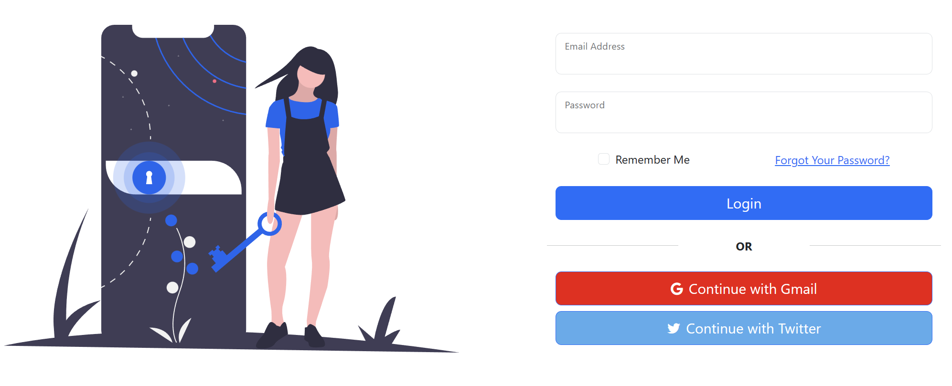

3

5

4

6

7

2

|  |  |  |  |  |  |
| --- | --- | --- | --- | --- | --- |
| **No** | **Name** | **Type** | **Validation** | **Description** | **Status** |
| 1 | Email | Textbox | Input not blank | Enter email | Enable |
| 2 | Password | Textbox | Input not blank | Enter password | Enable |
| 3 | Login | Button |  | Click to login | Enable |
| 4 | Login with google | Button |  | Click to login with Google | Enable |
| 5 | Login with Twitter | Button |  | Click to login with Twitter | Enable |
| 6 | Forgot-Password | Checkbox |  | Forgot password | Enable |
| 7 | Remember | Checkbox |  | Remember email&pass | Enable |

**2.Register**

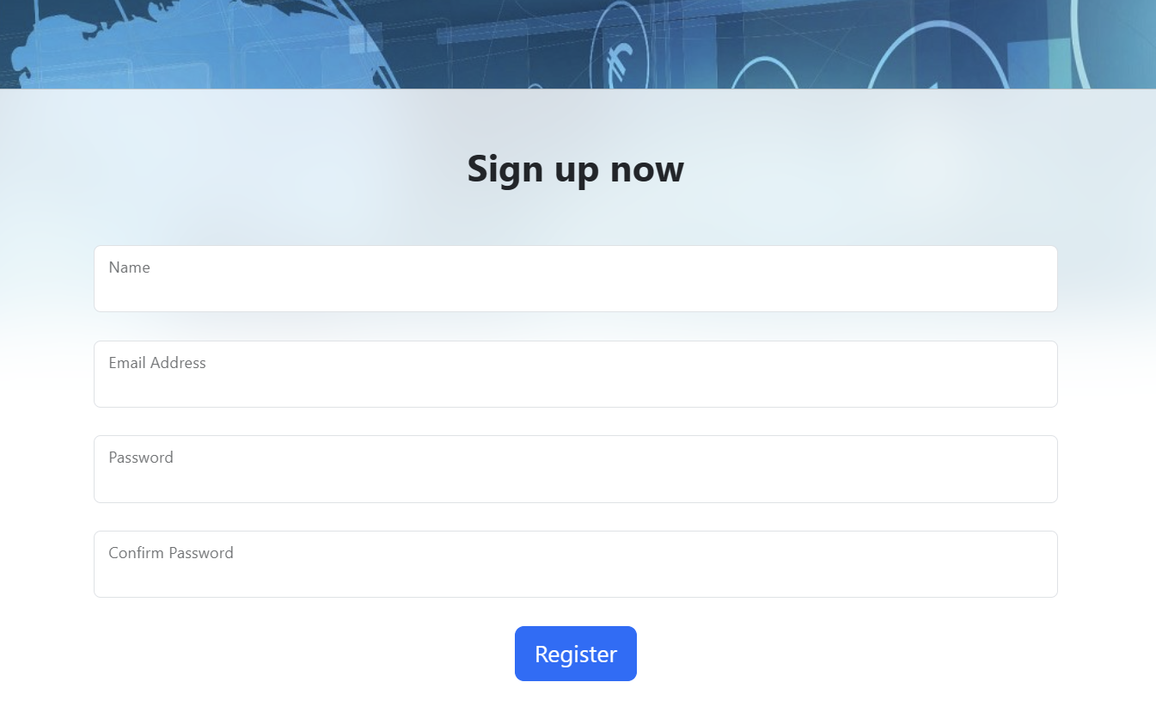

|  |  |  |  |  |  |
| --- | --- | --- | --- | --- | --- |
| **No** | **Name** | **Type** | **Validation** | **Description** | **Status** |
| 1 | Name | Textbox | Not null | Enter Name | Enable |
| 2 | Email | Textbox | Not null | Enter email | Enable |
| 3 | Password | Textbox | Not null | Enter password | Enable |
| 4 | Confirm Password | Textbox | Not null | ReEnter password | Enable |
| 5 | Register | Button |  | Click to go to Register | Enable |

**3.Forgot password**

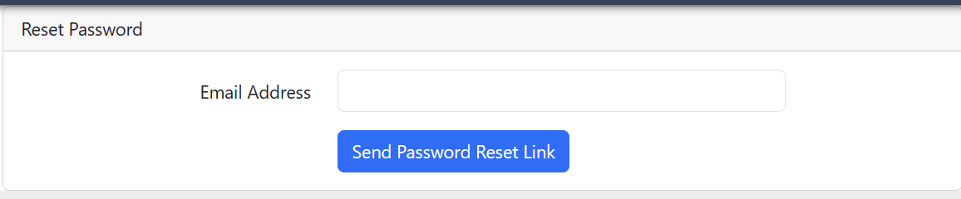

|  |  |  |  |  |  |
| --- | --- | --- | --- | --- | --- |
| **No** | **Name** | **Type** | **Validation** | **Description** | **Status** |
| 1 | Email Address | Textbox | Not null | Enter your email | Enable |
| 2 | Send Password Reset Link | Button |  | Click to go to Send password reset link to email | Enable |

**2.NavBar**

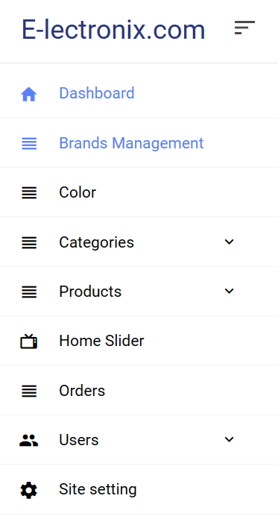

**1000**

**1**

**2**

**3**

**4**

**5**

**6**

**7**

**8**

**9**

|  |  |  |  |  |  |
| --- | --- | --- | --- | --- | --- |
| **No** | **Name** | **Type** | **Validation** | **Description** | **Status** |
| 1 | Shop Brand | Link |  | Click on to go to main Dashboard | Enable |
| 2 | Dashboard | Link |  | Click on to go to main Dashboard | Enable |
| 3 | Color | Link |  | Click on to go to Color Product | Enable |
| 4 | Categories | Link |  | Click on to go to Categories | Enable |
| 5 | Products | Link |  | Click on to go to Products | Enable |
| 6 | Home Slider | Link |  | Click on to go to manager Home Slider | Enable |
| 7 | Message of customer | Link |  | Click on to go Message of customer | Enable |
| 8 | Orders | Link |  | Click on to go orders | Enable |
| 9 | Users | Link |  | Click on to go User panel | Enable |
| 10 | Site Setting | Link |  | Click on to go Setting Dashboard | Enable |

**3.Admin Page**

**4**

**3**

**2**

**1**

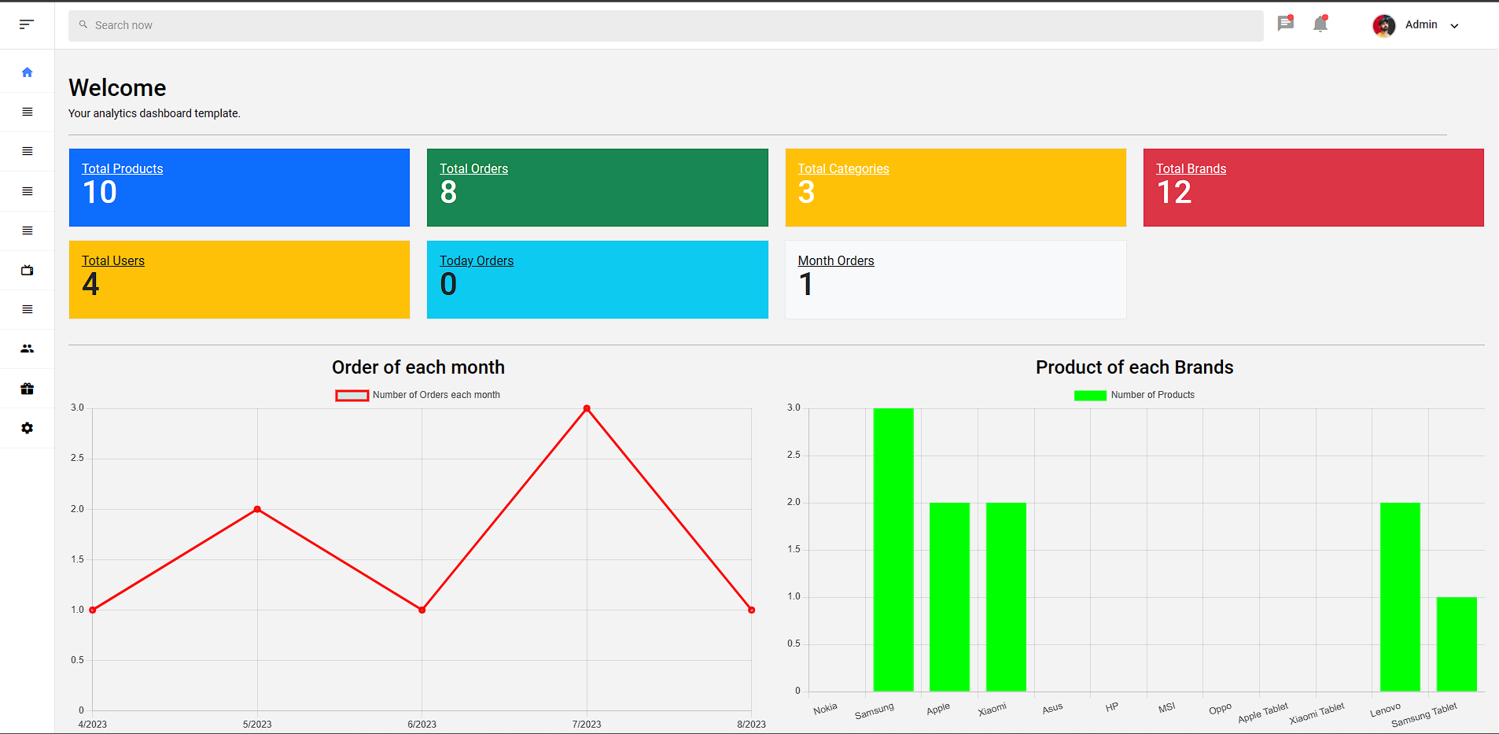

|  |  |  |  |  |  |
| --- | --- | --- | --- | --- | --- |
| **No** | **Name** | **Type** | **Validation** | **Description** | **Status** |
| 1 | User | Link |  | Click on to go to main Dashboard | Enable |

Brands Managerment:

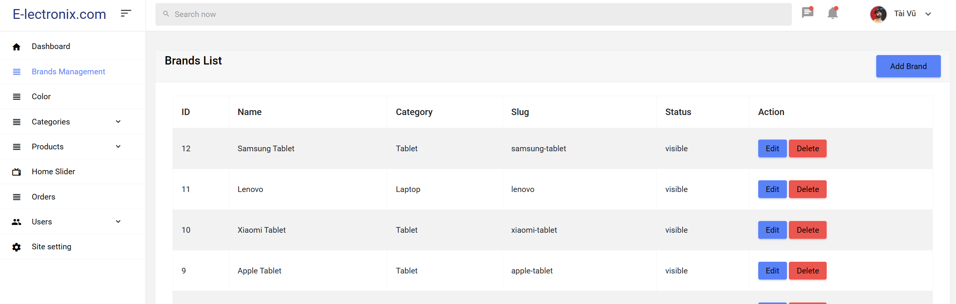

|  |  |  |  |  |  |
| --- | --- | --- | --- | --- | --- |
| **No** | **Name** | **Type** | **Validation** | **Description** | **Status** |
| 1 | Add Brand | Button |  | Click to add new brand | Enable |
| 2 | Edit | Button |  | Click to Edit brand | Enable |
| 3 | Delete | Button |  | Click to delete brand | Enable |

Color :

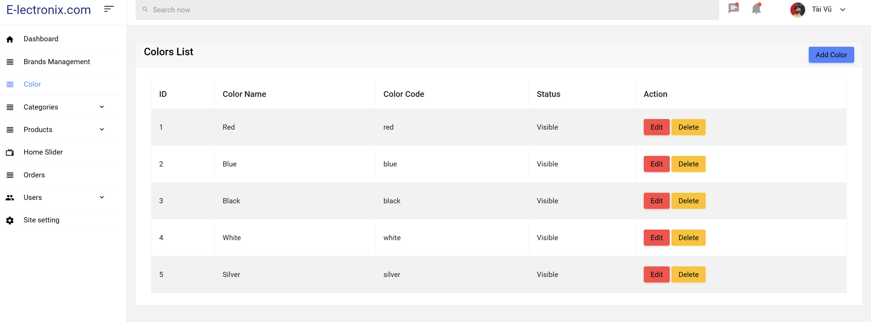

|  |  |  |  |  |  |
| --- | --- | --- | --- | --- | --- |
| **No** | **Name** | **Type** | **Validation** | **Description** | **Status** |
| 1 | Add color | Button |  | Click to add new product color | Enable |
| 2 | Edit | Button |  | Click to edit product color | Enable |
| 3 | Delete | Button |  | Click to delete product color | Enable |

Categories:

-Add Category

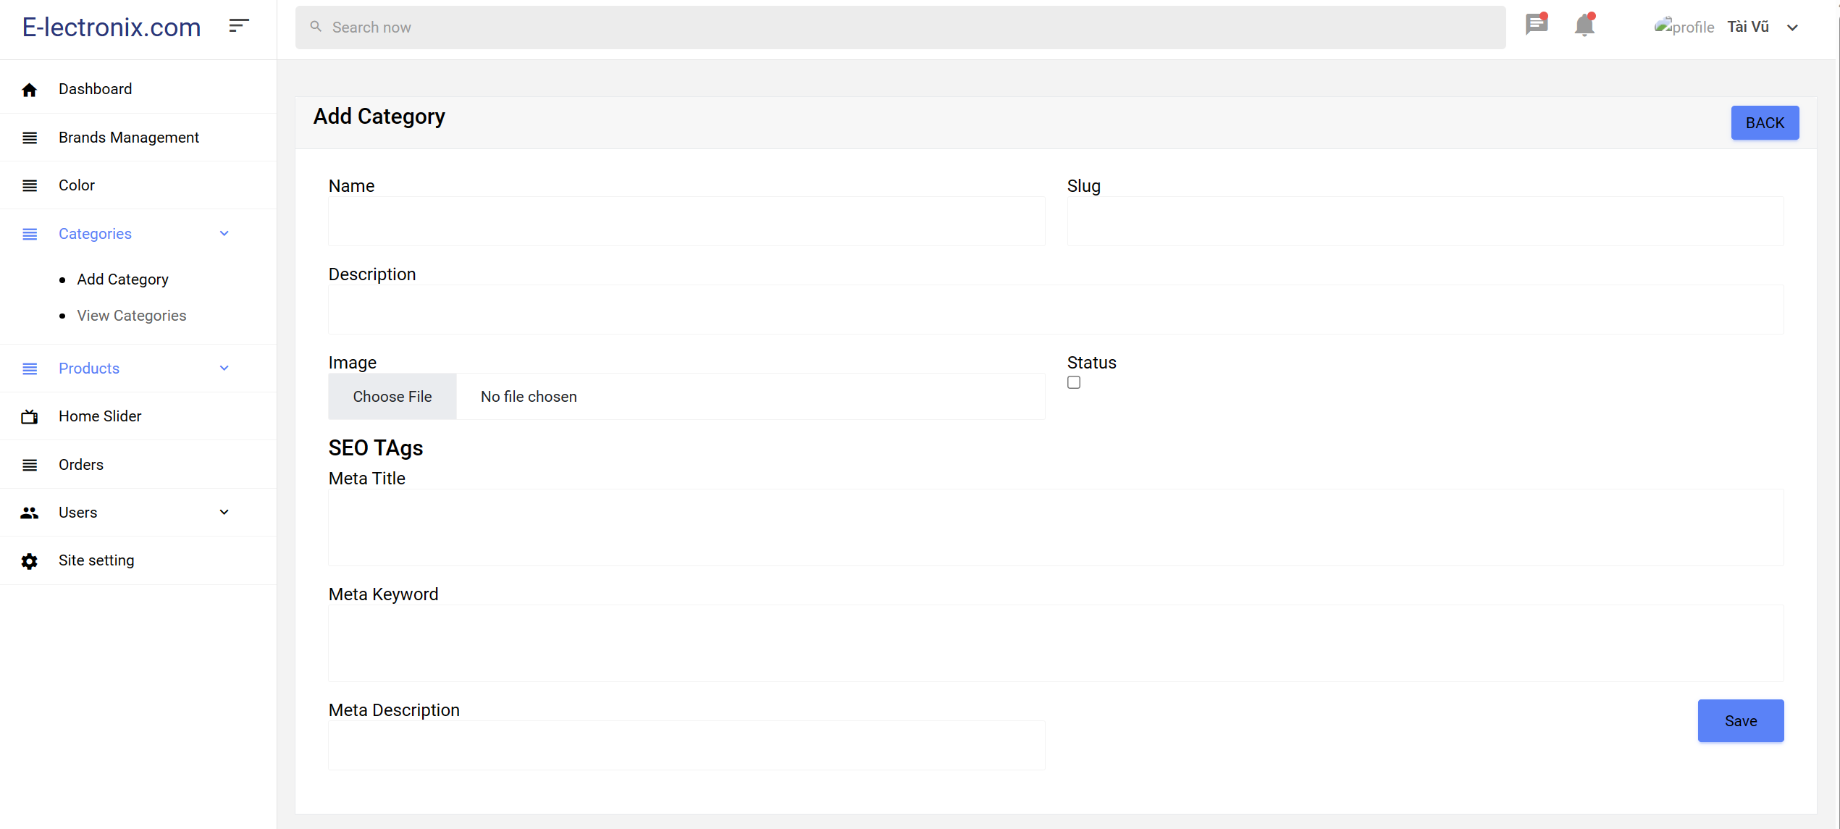

|  |  |  |  |  |  |
| --- | --- | --- | --- | --- | --- |
| **No** | **Name** | **Type** | **Validation** | **Description** | **Status** |
| 1 | Name | Input | Required | Name of category | Enable |
| 2 | Slug | Input | Required | Slug of category | Enable |
| 3 | Description | Input | Required | Description of category | Enable |
| 4 | Image | Input | Null able | Image of category | Enable |
| 5 | Status | Input | Null able | Check to hidden category | Uncheck |
| 6 | Meta Title | Input | Required | The meta title is the main title that appears in the browser's title bar when users access a category page. | Enable |
| 7 | Meta Keyword | Input | Required | Previously used for relevant keywords, meta keywords are now less relevant due to search engines disregarding them to prevent manipulation. | Enable |
| 8 | Meta Description | Input | Required | The meta description is a short snippet describing the category's content. It usually appears below the page title in search results, aiming to attract users to click on your link. | Enable |
| 9 | Save | Button |  | Click to Add new Category | Enable |

-View Category

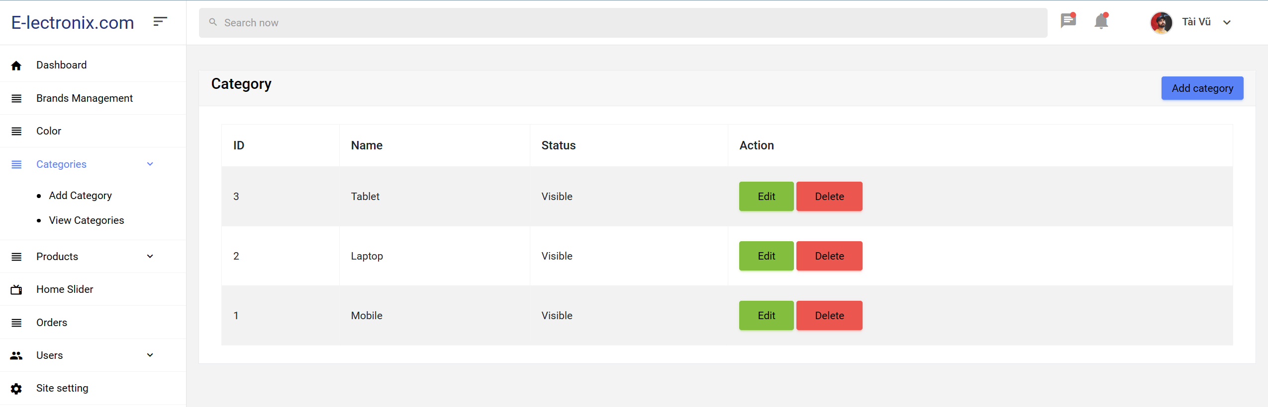

|  |  |  |  |  |  |
| --- | --- | --- | --- | --- | --- |
| **No** | **Name** | **Type** | **Validation** | **Description** | **Status** |
| 1 | Add category | Button |  | Click to Add new category | Enable |
| 2 | Edit | Button |  | Click to Edit category | Enable |
| 3 | Delete | Button |  | Click to Delete category | Enable |

Products:

-Add Product:

+Home:

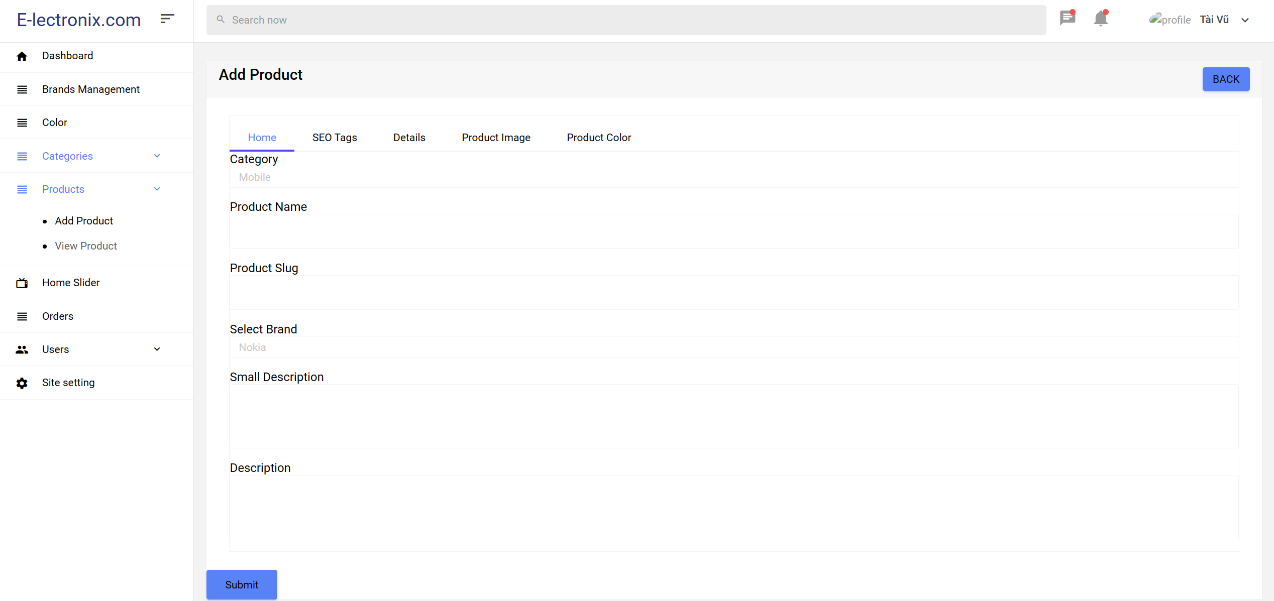

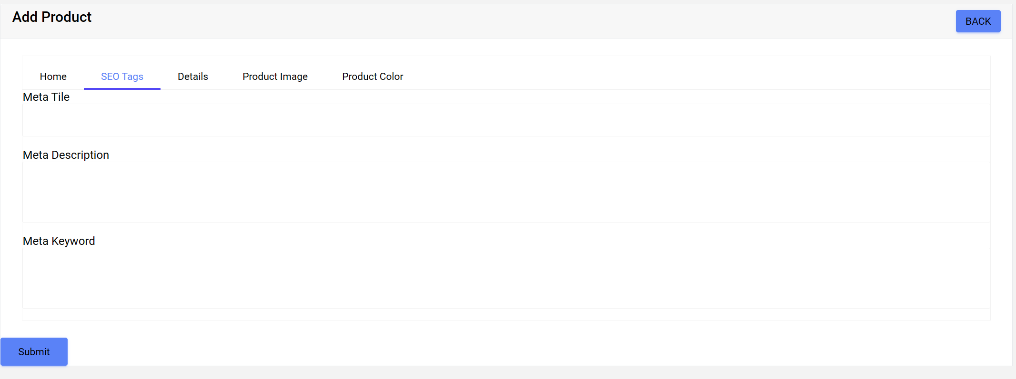

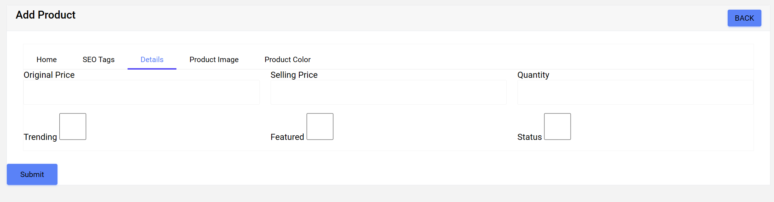

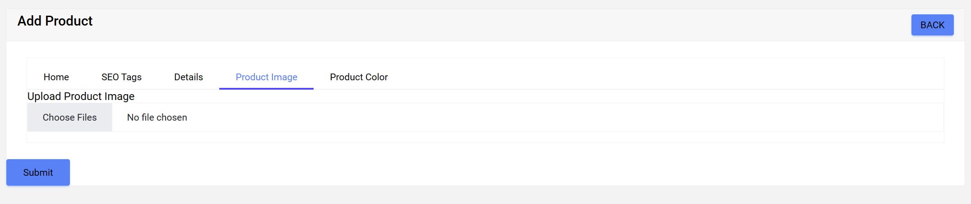

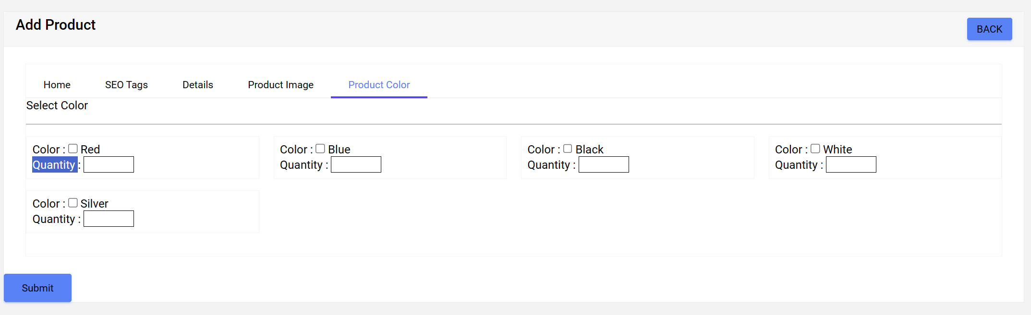

|  |  |  |  |  |  |
| --- | --- | --- | --- | --- | --- |
| **No** | **Name** | **Type** | **Validation** | **Description** | **Status** |
| 1 | Category | Selection | Required | Name of category | Enable |
| 2 | Product Name | Input | Required | Product name | Enable |
| 3 | Product Slug | Input | Required | Slug of Product | Enable |
| 4 | Select Brand | Selection | Required | Name of brand | Enable |
| 5 | Small Description | Input | Required | Short description of product | Uncheck |
| 6 | Description | Input | Required | The overview of product's features, benefits, and specifications, helping customers understand its value and purpose before making a purchase decision. | Enable |
| 7 | Meta Tile | Input | Required | The meta title is the main title that appears in the browser's title bar when users access a product page. | Enable |
| 8 | Meta Keyword | Input | Required | Previously used for relevant keywords, meta keywords are now less relevant due to search engines disregarding them to prevent manipulation. | Enable |
| 9 | Meta Description | Input | Required | The meta description is a short snippet describing the product’s content. It usually appears below the page title in search results, aiming to attract users to click on your link. | Enable |
| 9 | Original Price | Input | Required | Original Price | Enable |
| 10 | Selling Price | Input | Required | Selling Price | Enable |
| 11 | Quantity | Input | Required | Quantity of product | Enable |
| 12 | Trending | Checkbox | Null able | Check to add trending list | Uncheck |
| 13 | Featured | Checkbox | Null able | Check to add Featured list | Uncheck |
| 14 | Status | Checkbox | Null able | Check to hidden product | Uncheck |
| 15 | Upload Product Image | Input | Required | Upload multi image of product | Unchoice |
| 16 | Color | Checkbox | Null able | Check to add color of product | Uncheck |
| 17 | Quantity | Input | Null able | Input to add quantity of this color | Enable |
| 18 | Submit | Button |  | Click to add new product | Enable |

-View Product:

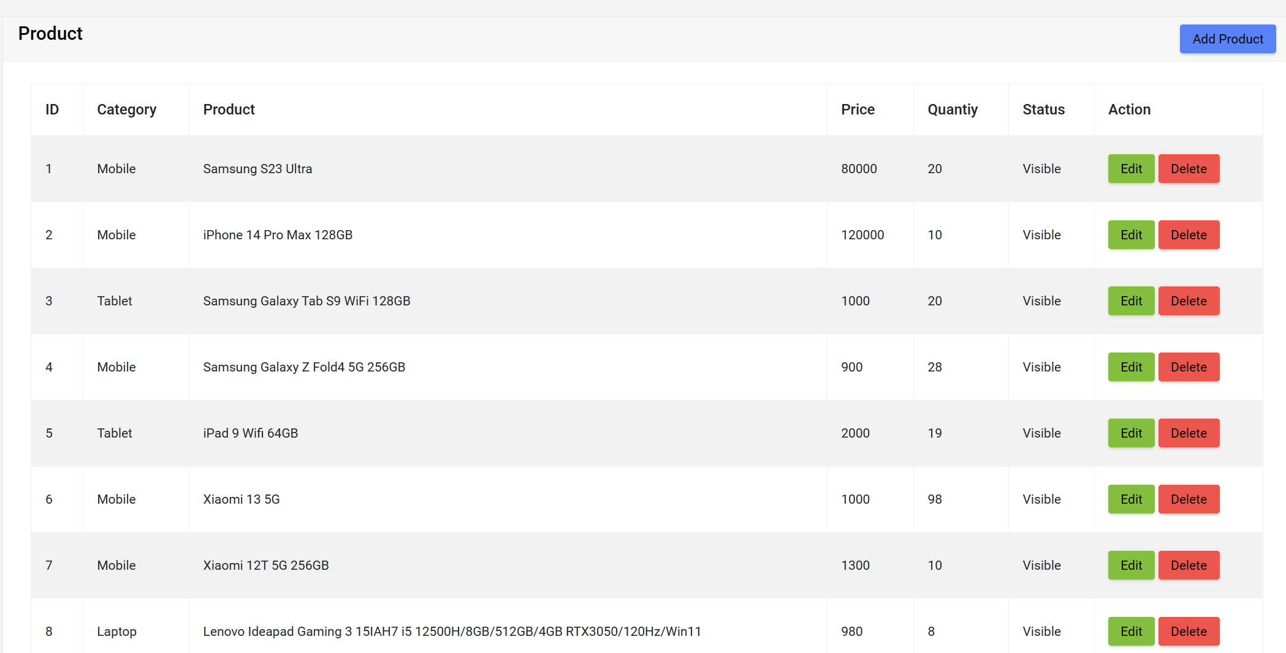

|  |  |  |  |  |  |
| --- | --- | --- | --- | --- | --- |
| **No** | **Name** | **Type** | **Validation** | **Description** | **Status** |
| 1 | Add Product | Button |  | Click to Add new Product | Enable |
| 2 | Edit | Button |  | Click to Edit Product | Enable |
| 3 | Delete | Button |  | Click to Delete Product | Enable |

**4.Home Slide**

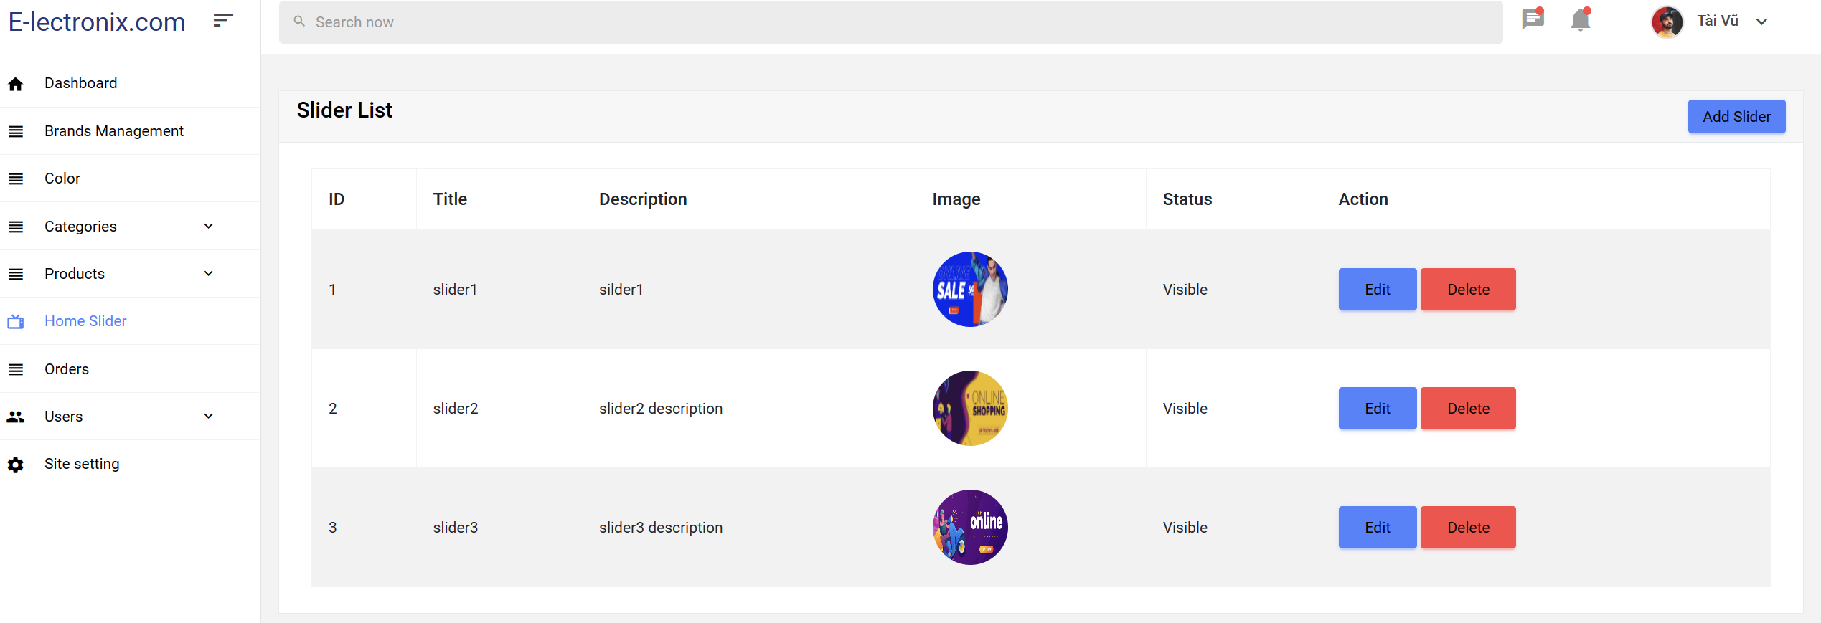

1

2

3

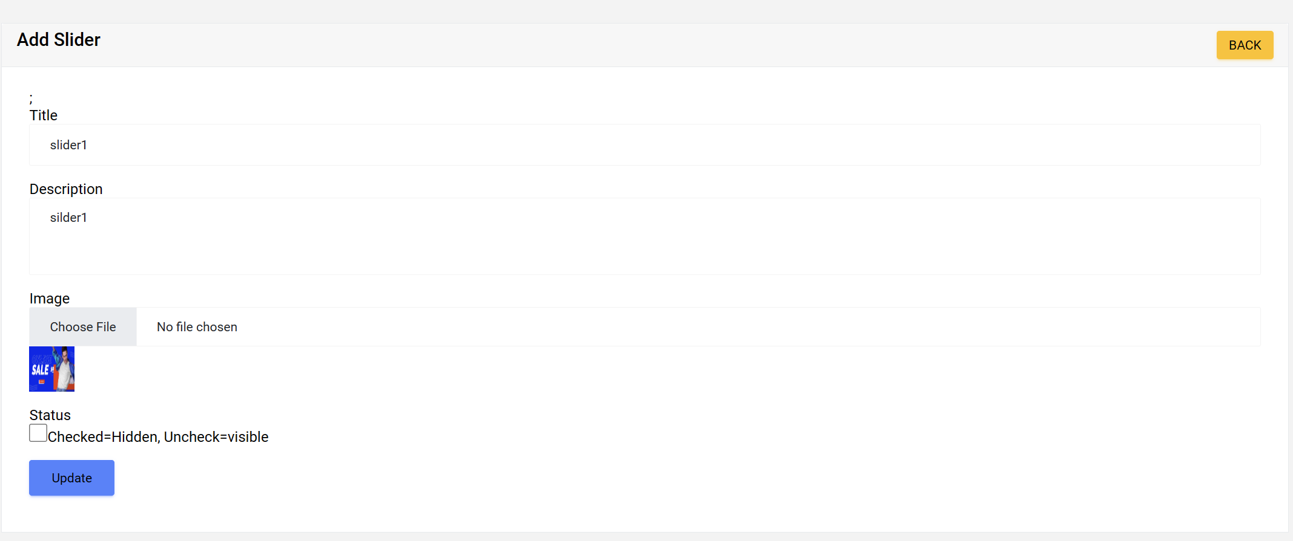

|  |  |  |  |  |  |
| --- | --- | --- | --- | --- | --- |
| **No** | **Name** | **Type** | **Validation** | **Description** | **Status** |
| 1 | Add Slider | Button |  | Click on to go to create new Slider | Enable |
| 2 | Edit | Button |  | Click on go to Edit Slider | Enable |
| 3 | Delete | Button |  | Click on to go to “delete Slider” | Enable |
| 4 | Title | Input |  | Title of Slider | Enable |
| 5 | Description | Input |  | Description of Slider | Enable |
| 6 | Image | Input |  | Image of Slider | Enable |
| 7 | Status | Checkbox |  | Check to hidden Slider | Enable |
| 8 | Update | Button |  | Click on to go to update Slider | Enable |

**5.Odders**

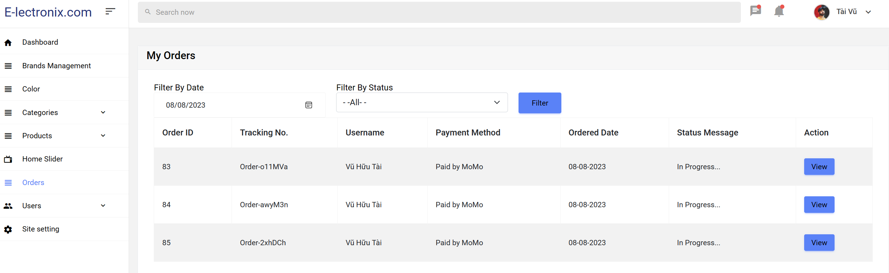

2

3

|  |  |  |  |  |  |
| --- | --- | --- | --- | --- | --- |
| **No** | **Name** | **Type** | **Validation** | **Description** | **Status** |
| 1 | Filter By Date | Date | Null able | Choice to filter by date | Enable |
| 2 | Filter By Status | Selection | Null able | Select to filter by Status | Enable |
| 3 | Filter | Button |  | Click to Filter Oder | Enable |
| 4 | View | Button |  | Click to go to View Oder details | Enable |

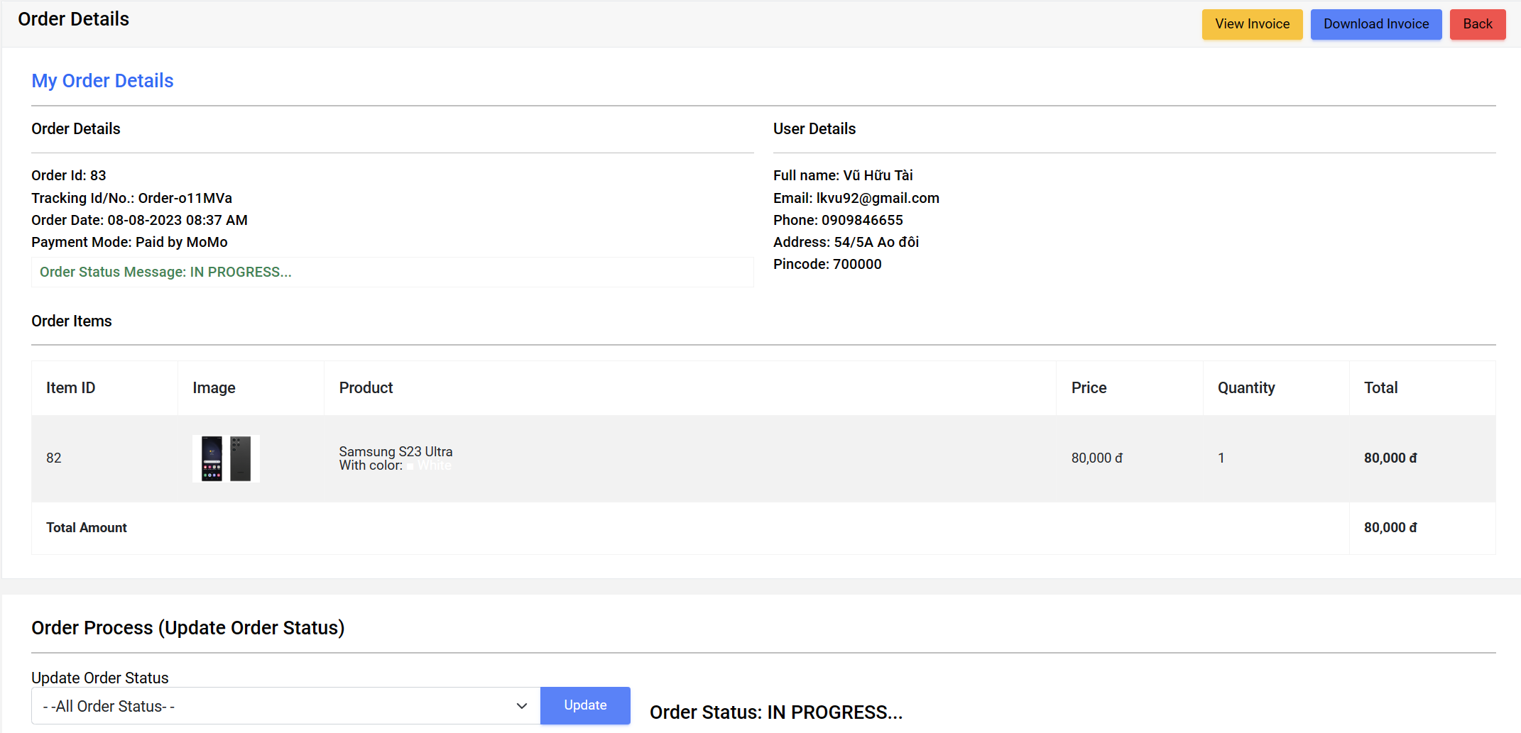

|  |  |  |  |  |  |
| --- | --- | --- | --- | --- | --- |
| **No** | **Name** | **Type** | **Validation** | **Description** | **Status** |
| 1 | View Invoice | Button |  | Click to go to View Invoice | Enable |
| 2 | Download Invoice | Button |  | Click to go to Download Invoice | Enable |
| 3 | Back | Button |  | Click to go to Back | Enable |
| 4 | Update Order Status | Selection |  | Select to change Order Status | Enable |
| 5 | Update | Button |  | Click to go to Update Order Status | Enable |

**6.User**

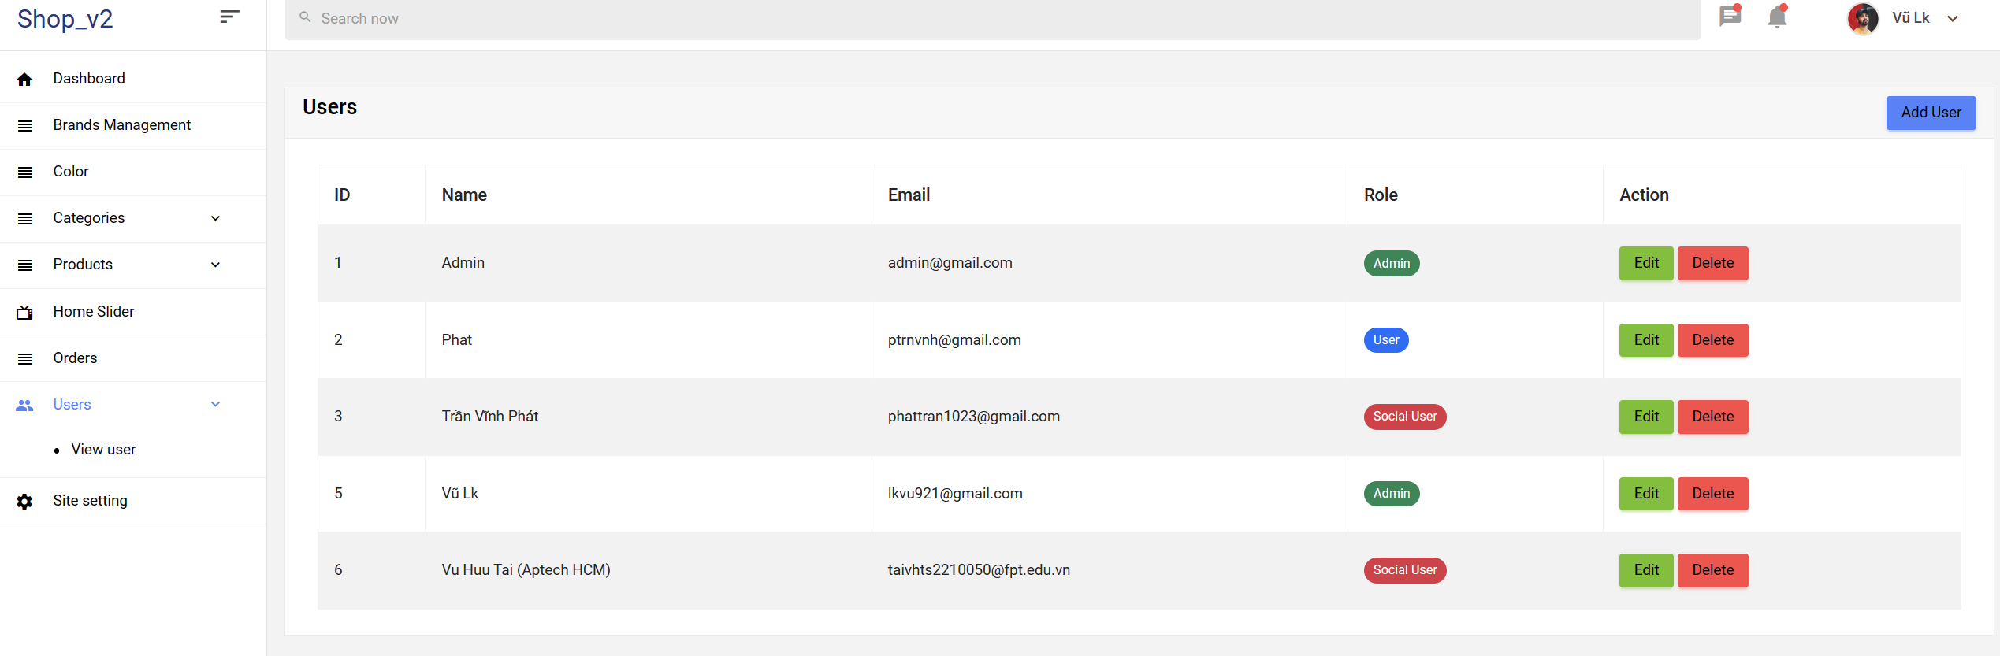

|  |  |  |  |  |  |
| --- | --- | --- | --- | --- | --- |
| **No** | **Name** | **Type** | **Validation** | **Description** | **Status** |
| 1 | Add User | Button |  | Click to go to Add user | Enable |
| 2 | Edit | Button |  | Click to go to Edit user information | Enable |
| 3 | Delete | Button |  | Click to go to Delete user | Enable |

- Add User

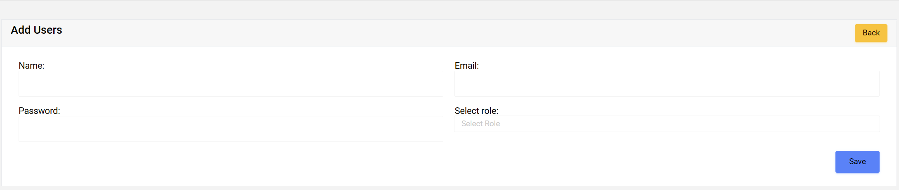

|  |  |  |  |  |  |
| --- | --- | --- | --- | --- | --- |
| **No** | **Name** | **Type** | **Validation** | **Description** | **Status** |
| 1 | Back | Button |  | Click to go to back User page | Enable |
| 2 | Name | Input | Not Null | Enter name of new user | Enable |
| 3 | Email | Input | Not Null | Enter Email of new user | Enable |
| 4 | Password | Input | Not Null | Enter Password of new user | Enable |
| 5 | Role | Selection | Not Null | Select Role of new user | Enable |
| 6 | Save | Button |  | Click to go to Create new user | Enable |

- Edit User

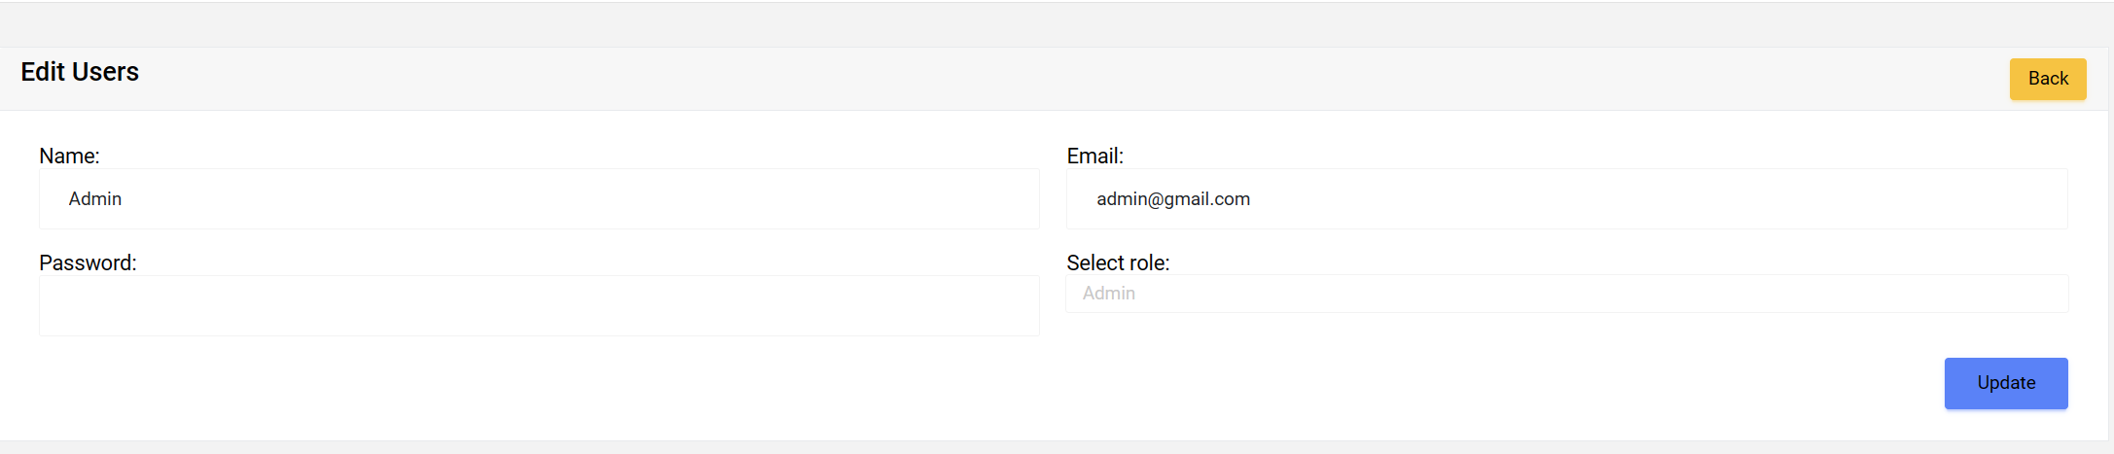

|  |  |  |  |  |  |
| --- | --- | --- | --- | --- | --- |
| **No** | **Name** | **Type** | **Validation** | **Description** | **Status** |
| 1 | Back | Button |  | Click to go to back User page | Enable |
| 2 | Name | Input | Not Null | Change name of new user | Enable |
| 3 | Email | Input | Not Null | Change Email of new user | Enable |
| 4 | Password | Input | Not Null | Change Password of new user | Enable |
| 5 | Role | Selection | Not Null | Select Role of user | Enable |
| 6 | Update | Button |  | Click to go to update user infomation | Enable |

- Delete

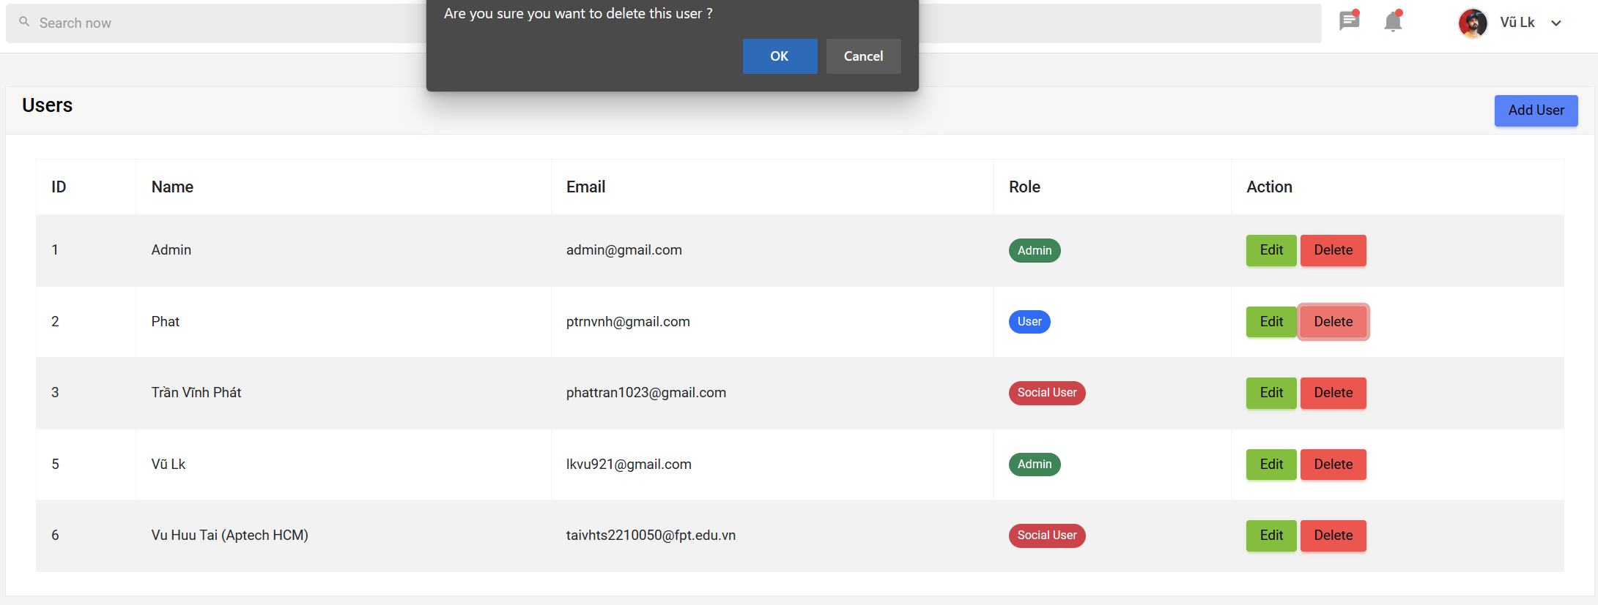

|  |  |  |  |  |  |
| --- | --- | --- | --- | --- | --- |
| **No** | **Name** | **Type** | **Validation** | **Description** | **Status** |
| 1 | OK | Button |  | Click to go to confirm delete this user | Enable |
| 2 | Cancel | Button |  | Click to go to cancel | Enable |

**7.Site Setting**

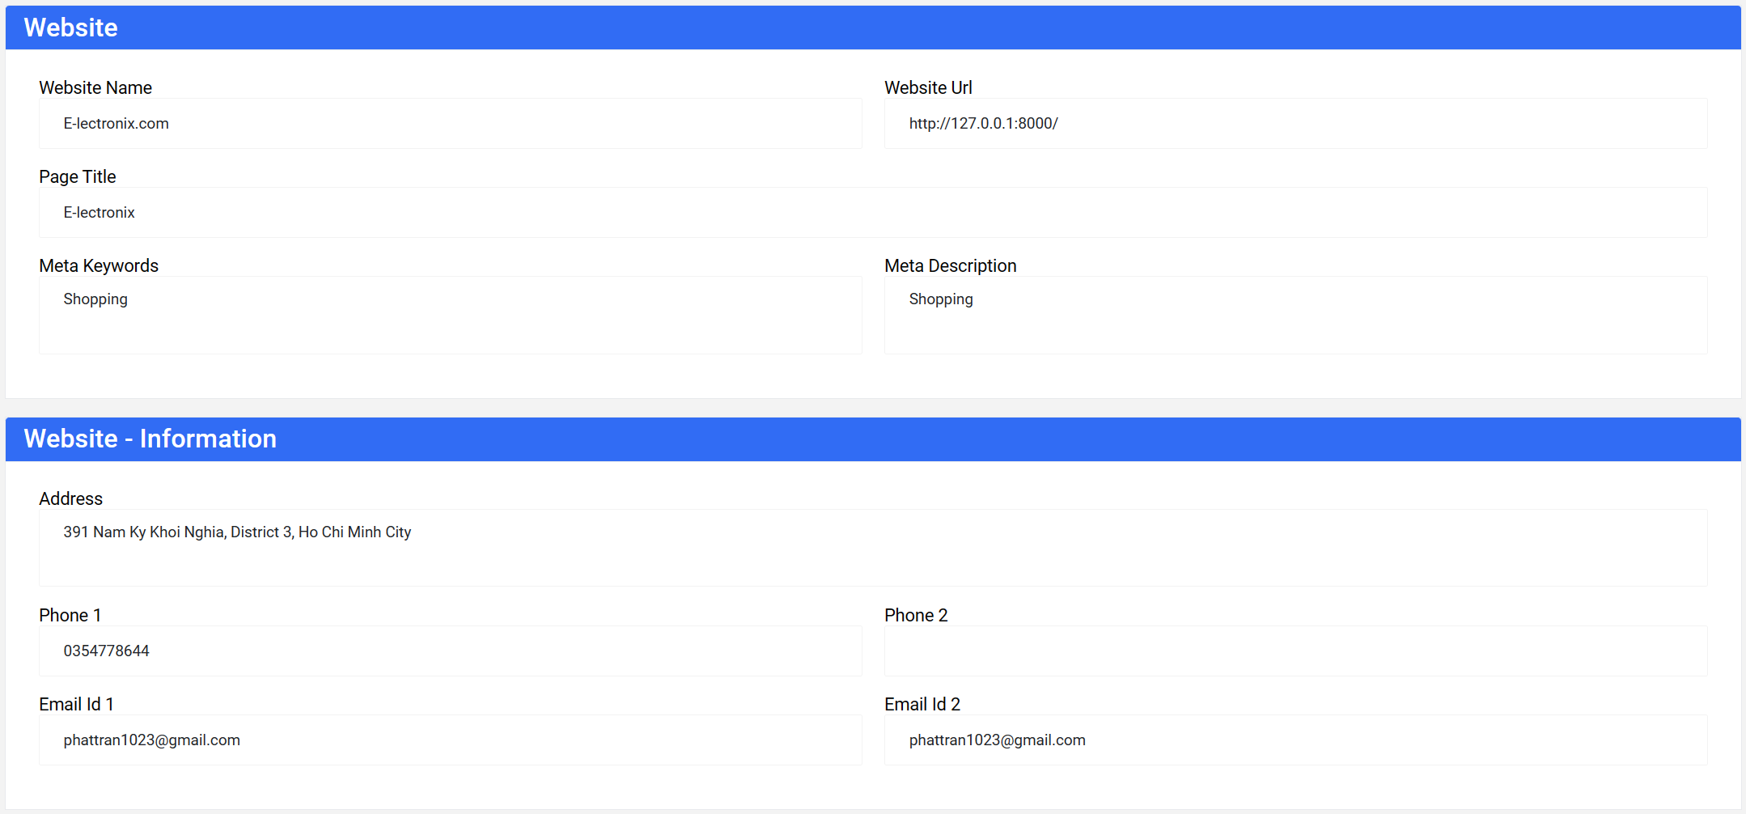

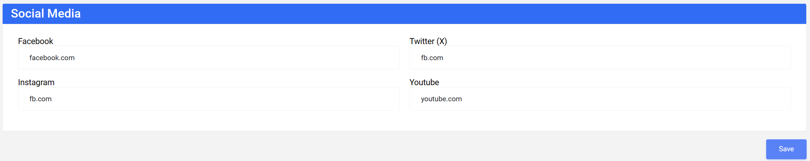

|  |  |  |  |  |  |
| --- | --- | --- | --- | --- | --- |
| **No** | **Name** | **Type** | **Validation** | **Description** | **Status** |
| 1 | Website Name | Input | Not Null | The name of the website. | Enable |
| 2 | Website Url | Input | Not Null | The official web address of the site. | Enable |
| 3 | Page Title | Input | Not Null | The title of the webpage. | Enable |
| 4 | Meta Keywords | Input | Nullable | Keywords relevant to the page's content, aiding search engines in better understanding the page's topic. | Enable |
| 5 | Meta Description | Input | Nullable | A concise description of the webpage's content, usually displayed in search results to attract users to click through. | Enable |
| 6 | Address | Input | Nullable | Contact address of the organization or business. | Enable |
| 7 | Phone 1 | Input | Nullable | Primary contact phone number. | Enable |
| 8 | Phone 2 | Input | Nullable | Secondary phone number. | Enable |
| 9 | Email Id 1 | Input | Nullable | Official email address for contact. | Enable |
| 10 | Email Id 2 | Input | Nullable | Secondary email address. | Enable |
| 11 | Facebook | Input | Nullable | Link to the official Facebook page of the website. | Enable |
| 12 | Twitter (X) | Input | Nullable | Link to the official Twitter page of the website. | Enable |
| 13 | Instagram | Input | Nullable | Link to the official Twitter page (if applicable) of the website. | Enable |
| 14 | Youtube | Input | Nullable | Link to the official YouTube channel of the website. | Enable |
| 15 | Save | Button |  | Update information | Enable |

1. **Web Shop**

**1.Header**



|  |  |  |  |  |  |
| --- | --- | --- | --- | --- | --- |
| **No** | **Name** | **Type** | **Validation** | **Description** | **Status** |
| 1 | Website Brand | Link |  | The Brand of the website. | Enable |
| 2 | Search bar | Input |  | Enter product information to search | Enable |
| 3 | Search Button | Button |  | Click to go to Search | Enable |
| 4 | Cart | Button |  | Click to go to Shopping cart | Enable |
| 5 | Wishlist | Button |  | Click to go to Wishlist | Enable |
| 6 | User | Dropdown menu |  | Click to User menu | Enable |
| 7 | NavBar | Link |  | Click to view products by each category. | Enable |

-User menu:

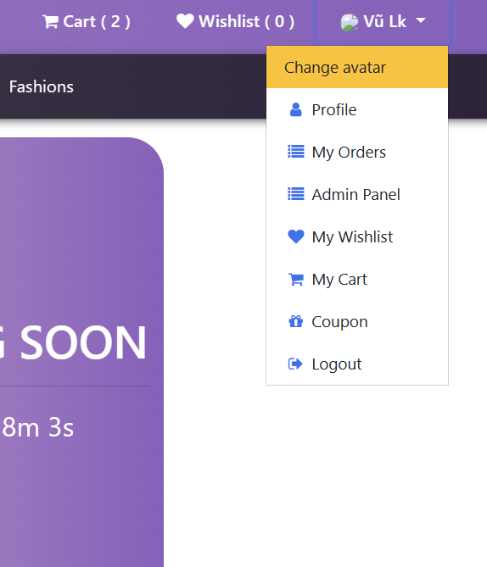

|  |  |  |  |  |  |
| --- | --- | --- | --- | --- | --- |
| **No** | **Name** | **Type** | **Validation** | **Description** | **Status** |
| 1 | Change avatar | Link |  | Click to go to change user avatar image | Enable |
| 2 | Profile | Link |  | Click to go to Profile page | Enable |
| 3 | My Orders | Link |  | Click to go to Order page | Enable |
| 4 | Admin Panel | Link |  | Click to go to admin dashboard page (if you are admin) | Enable |
| 5 | My Whishlist | Link |  | Click to go to Whishlist page | Enable |
| 6 | My Cart | Link |  | Click to go to shoping cart page | Enable |
| 7 | Coupon | Link |  | Click to go to coupon page | Enable |
| 8 | Logout | Link |  | Click to go to log out | Enable |

**2.Footer**

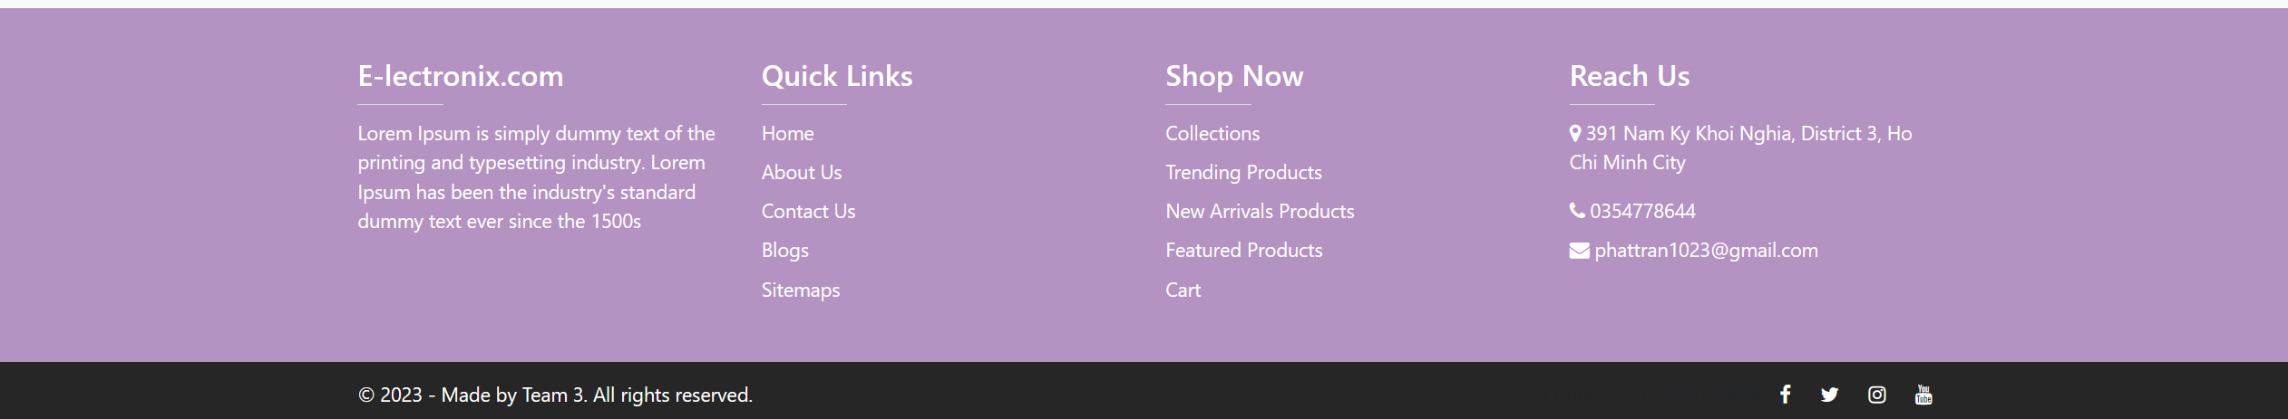

The footer on the E-lectronix.com website includes the following sections and their corresponding functionalities:

* Quick Links: This section provides quick links to other important pages on the website, making it easy for users to navigate to key topics.
* Home: Links to the homepage, allowing users to return to the main page of the website.
* About Us: Links to the page that introduces E-lectronix.com, providing information about the company's history, mission, and values.
* Contact Us: Links to the contact page, enabling users to get in touch with the company to ask questions or provide feedback.
* Blogs: Links to the blog page, where articles, news, and information related to the website's product field are published.
* Sitemaps: Links to the sitemap page, giving users an overview of the website's structure.
* Shop Now: Links to the shop page, allowing users to access product categories for shopping.
* Collections: Links to the page showcasing product collections, where users can view products organized into specific categories.
* Trending Products: Links to the page displaying trending products, helping users keep track of popular items.
* New Arrival Products: Links to the page featuring new products, enabling users to see recently launched items.
* Featured Products: Links to the page highlighting featured products, often showcasing products that the company honors or specially introduces.
* Cart: Links to the shopping cart page, where users can view and modify items added to their cart before proceeding to checkout.
* Additionally, the "Reach Us" section provides the company's contact information, including address, phone number, and email address, so users can get in touch when needed.

**3.Home page**

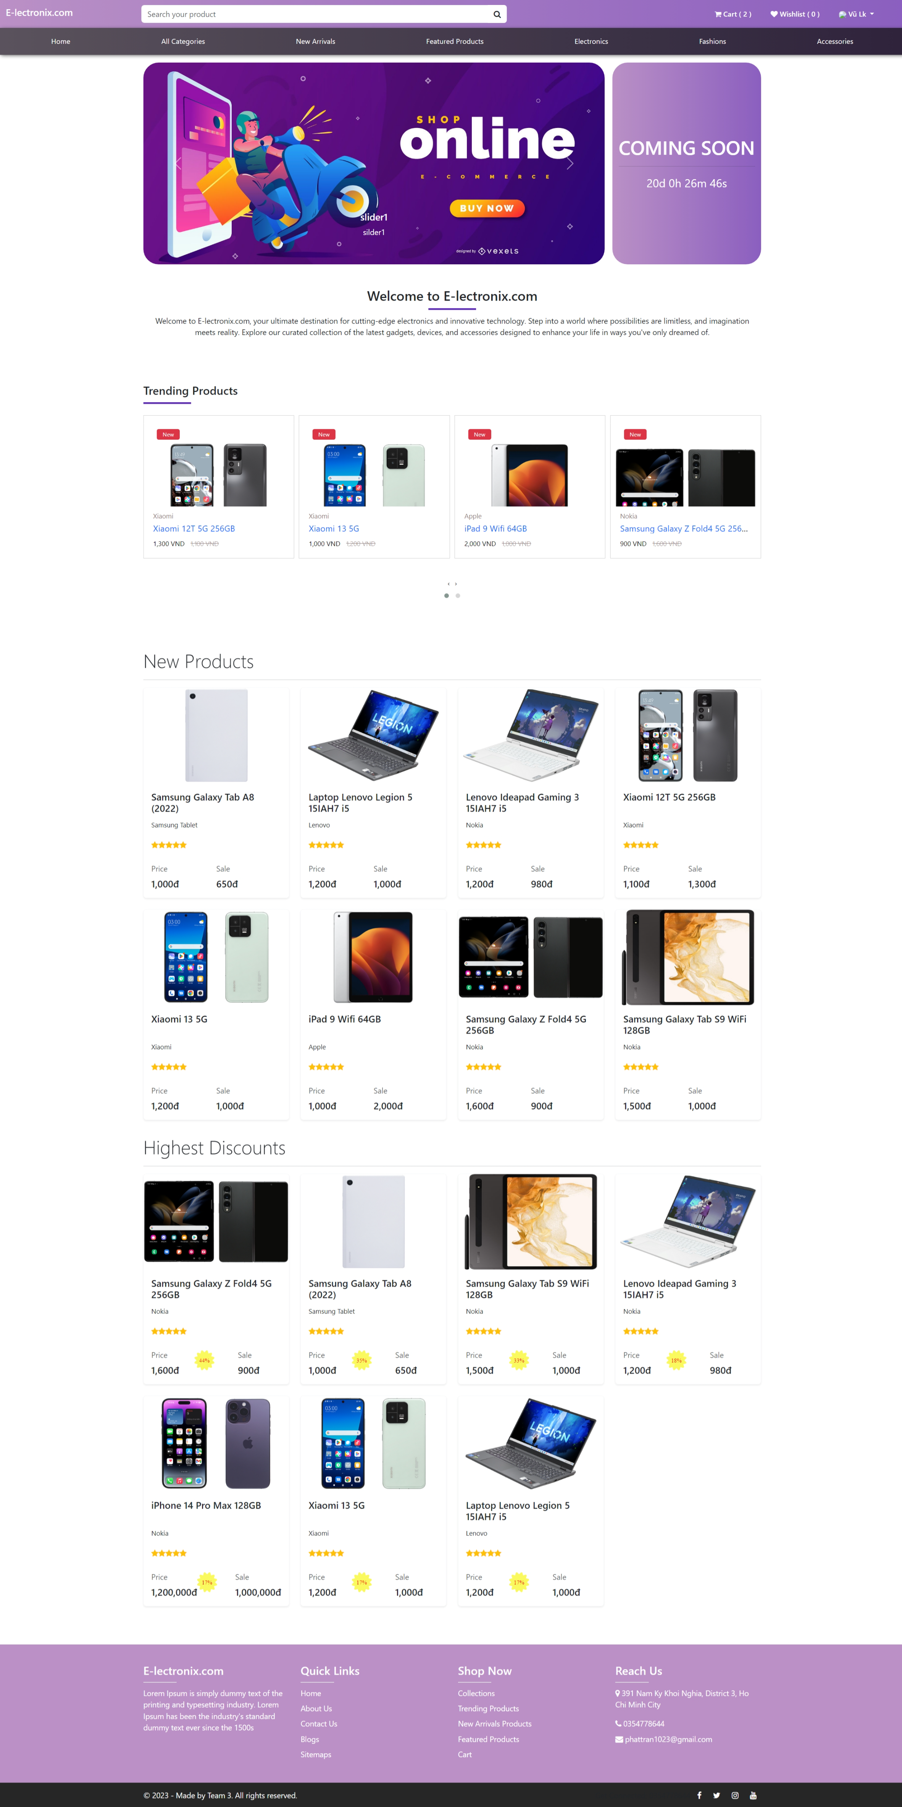

The "Home" section includes:

* Carousel for showcasing information about upcoming events.
* Most popular product categories.
* Latest product categories.
* Best deals product categories.

**4.All Categories**

"All Categories" encompasses all product brands and labels.

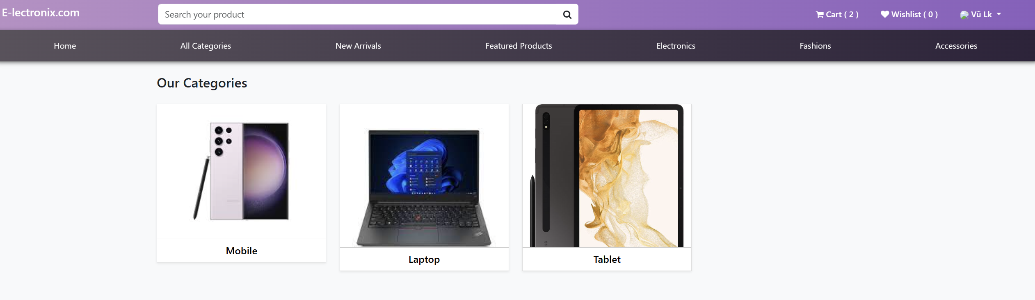

**5.New Arrivals**

The page featuring new products, enabling users to see recently launched items.

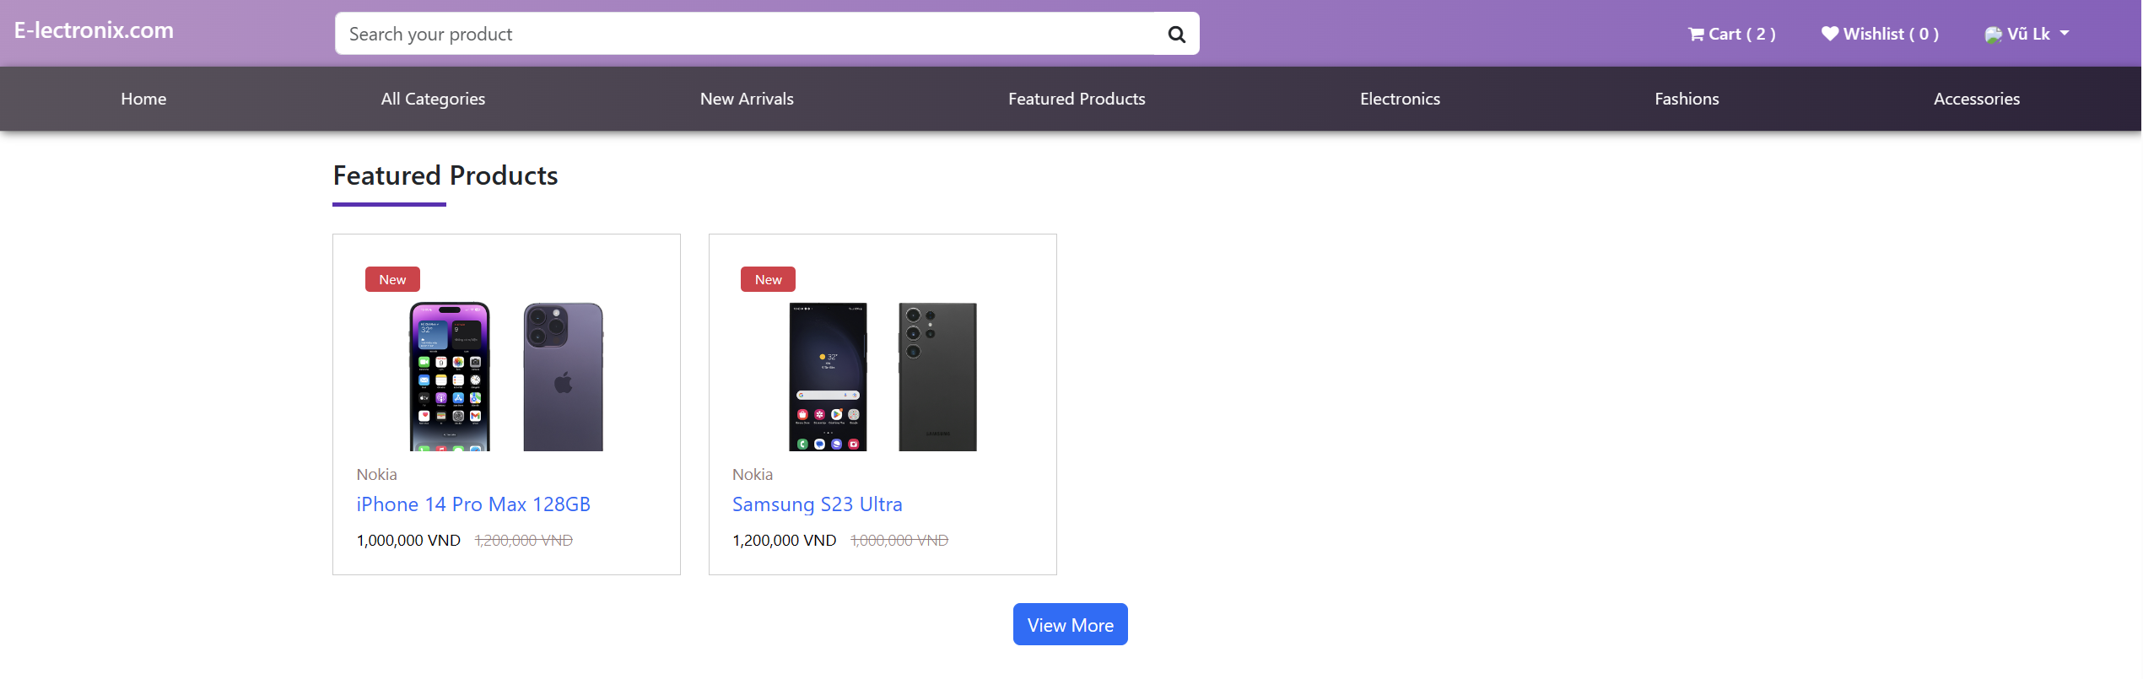

**6.Featured Products**

The page highlighting featured products, often showcasing products that the company honors or specially introduces.

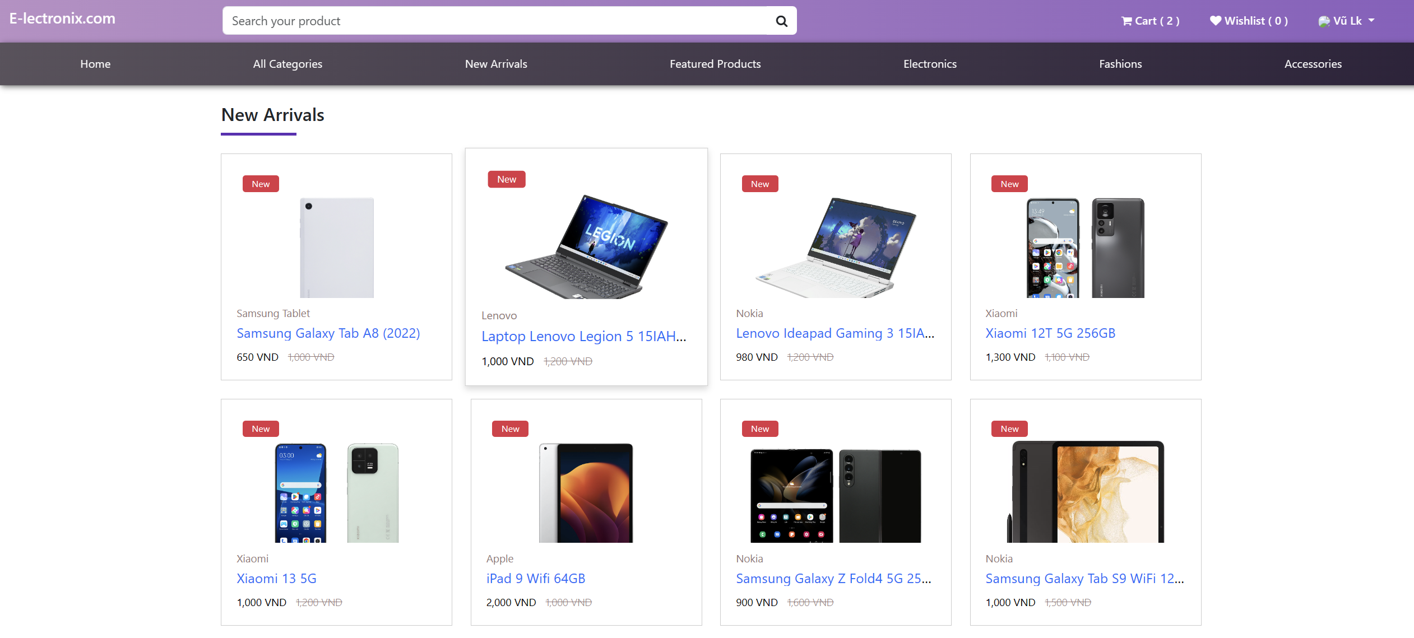

**7. Product page**

The product page contains products belonging to the selected category

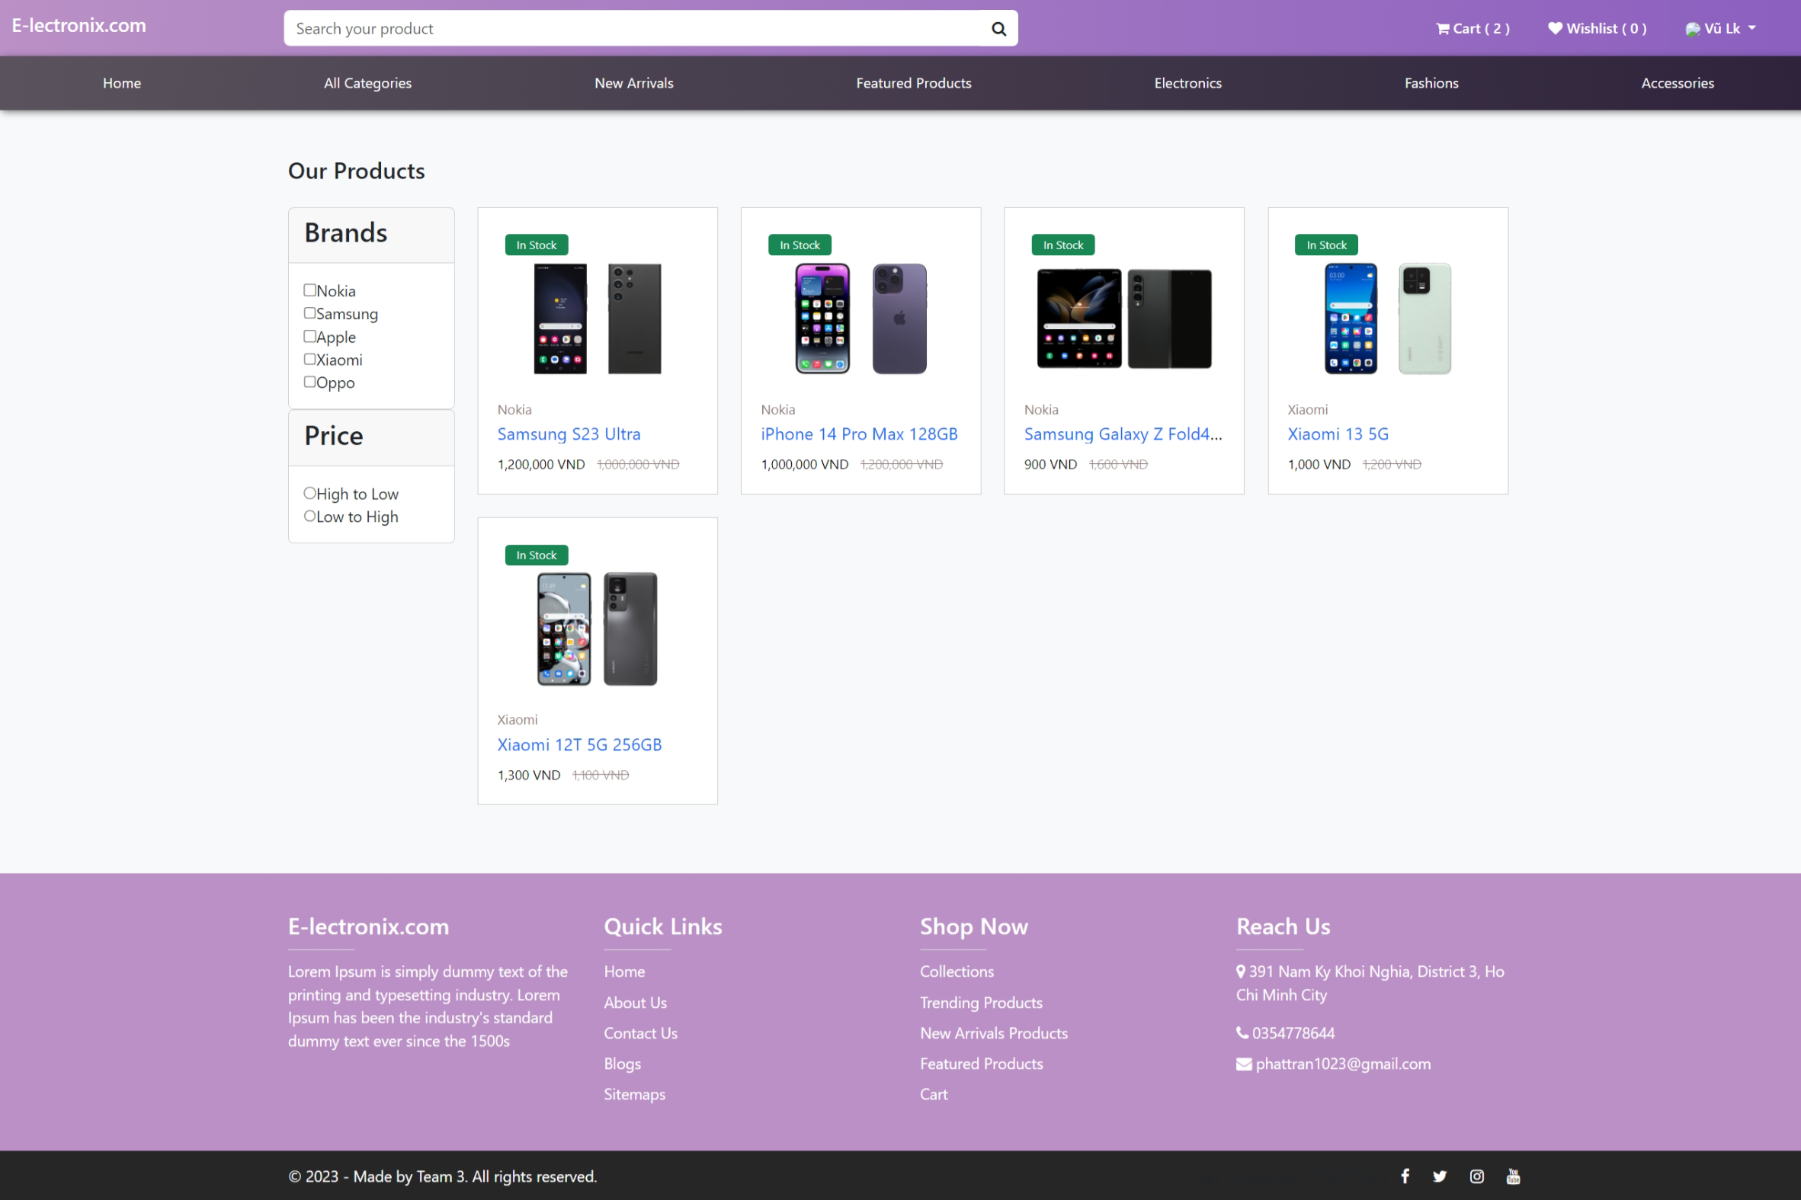

**8. Product detail page**

. The product page details contain comprehensive information about the product And customer comments, reviews, and inquiries, as well as responses to inquiries from the sales administrator, are also included.

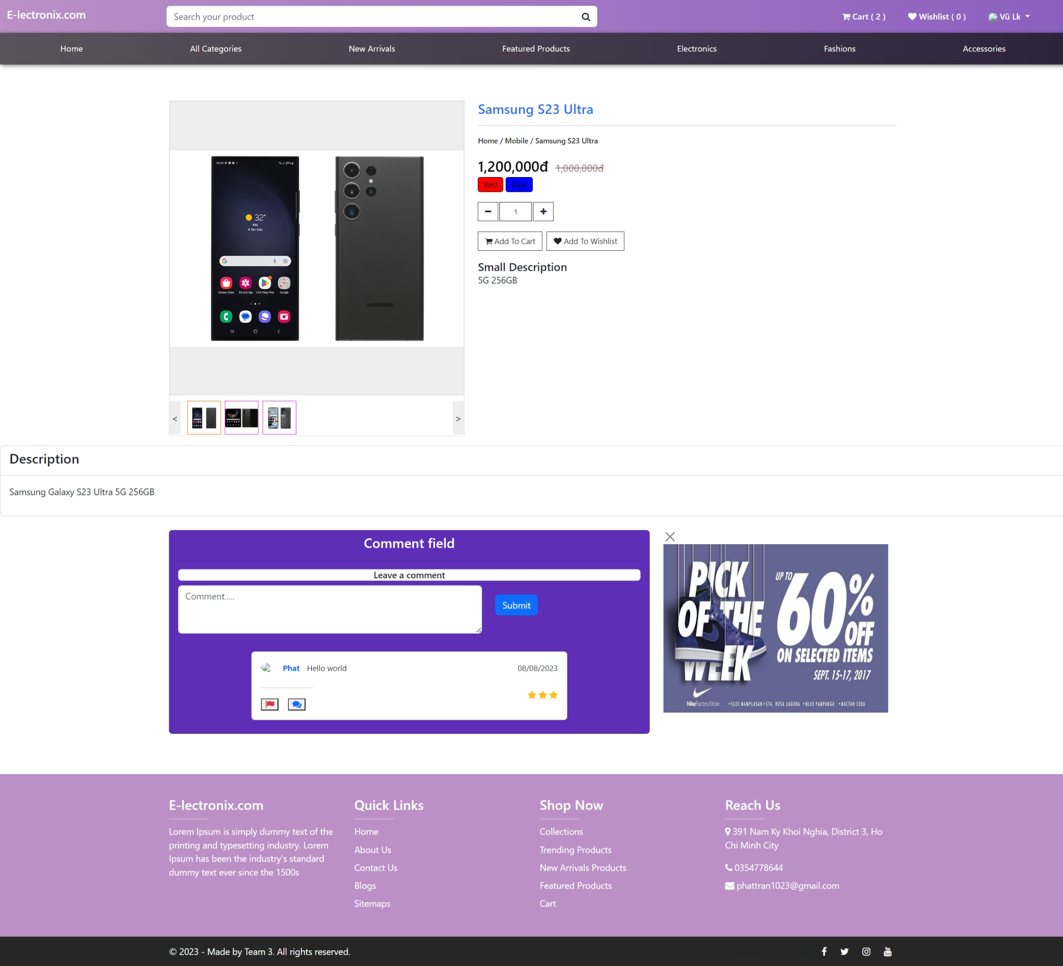

**9. Cart page**

The cart page contains information about the selected products in preparation for payment.

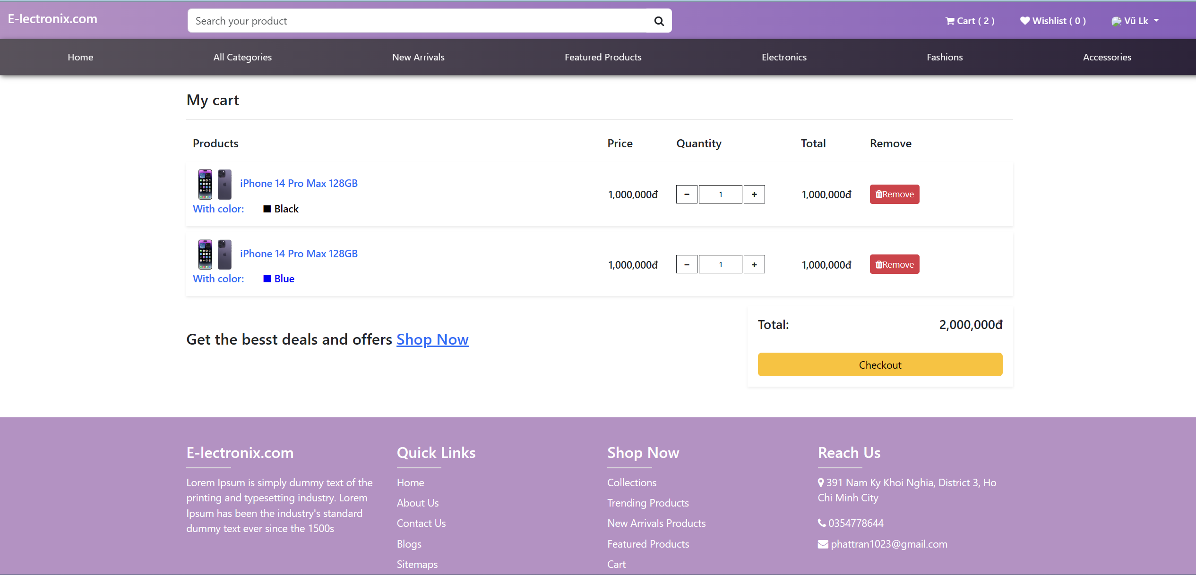

*- Payment page*

The Payment page contains invoice details for delivery and selection of payment method.

*+Payment COD*

COD stands for "Cash on Delivery," which is a payment method where you pay for the goods when they are delivered to you.

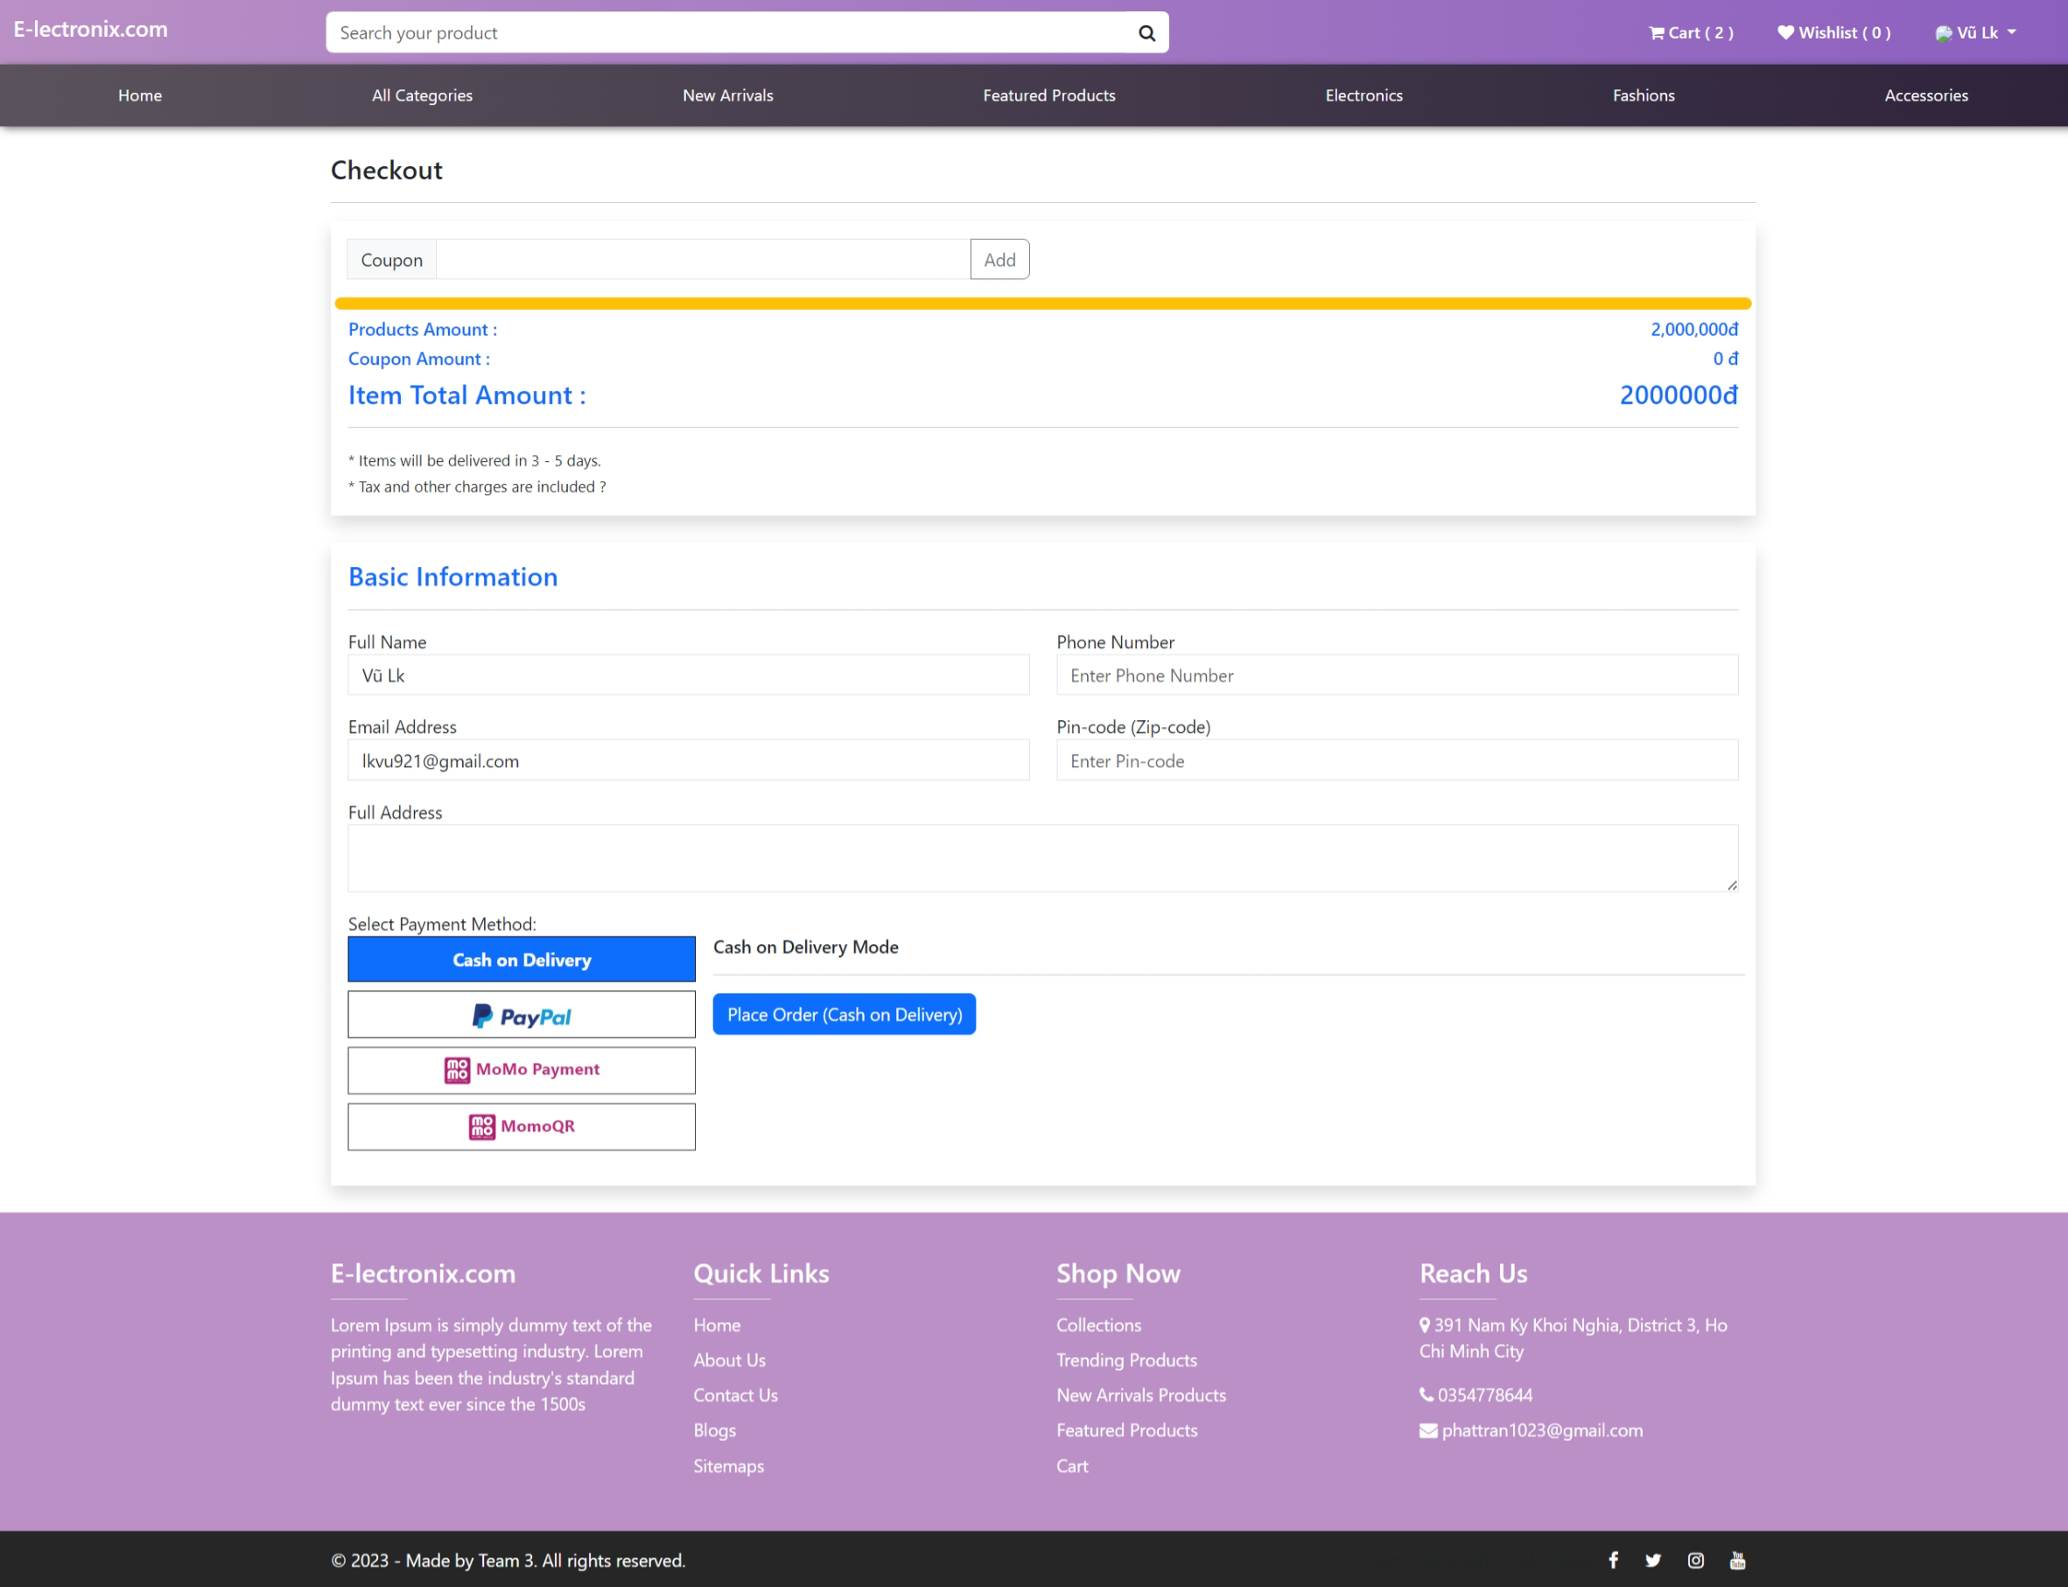

*+Payment Paypal*

PayPal is an online payment method that allows you to make payments using your PayPal account.

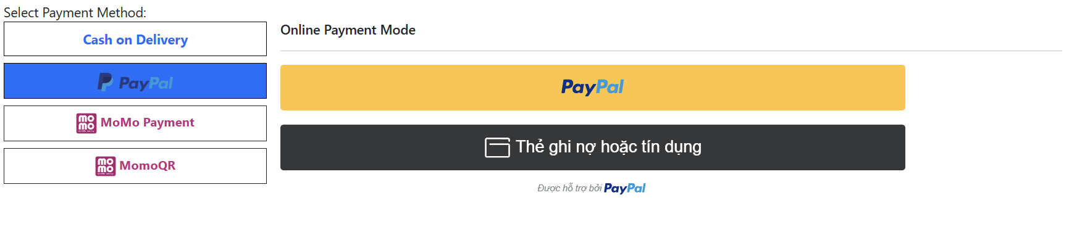

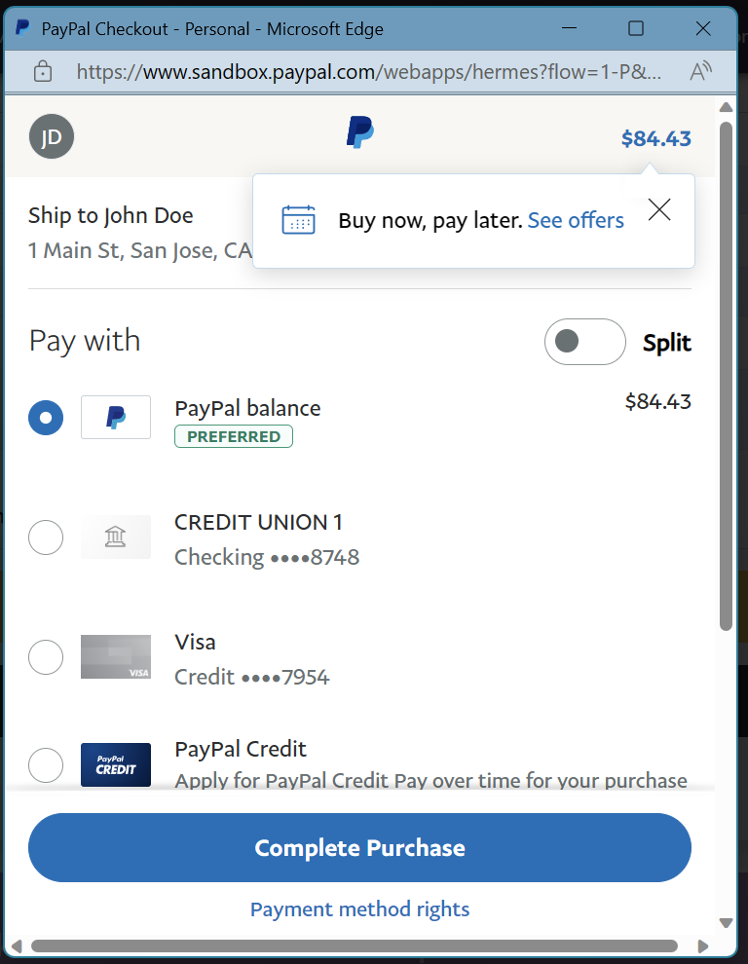

*+Payment Momo ATM*

ATM Momo is an online payment method that supports payment using various ATM cards supported by Momo.

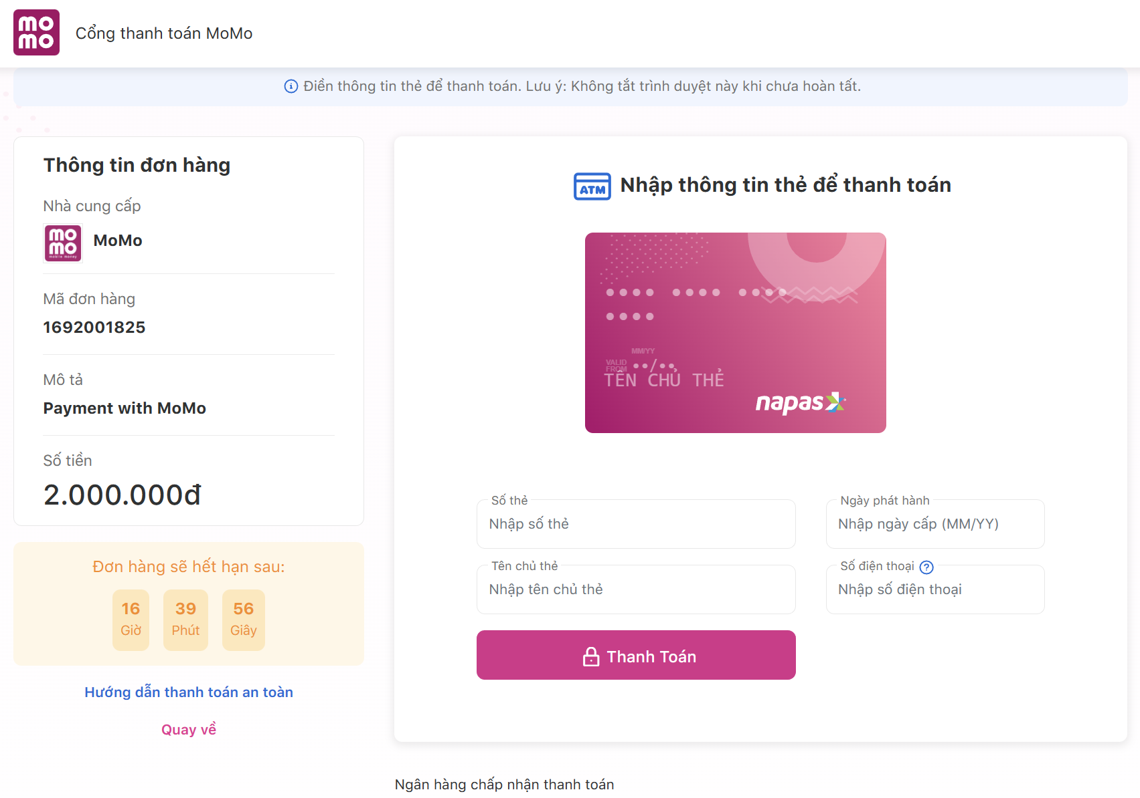

*+Payment MomoQR*

MomoQR is an online payment method that involves scanning QR codes through the Momo mobile application, providing a flexible and convenient way to make payments.

